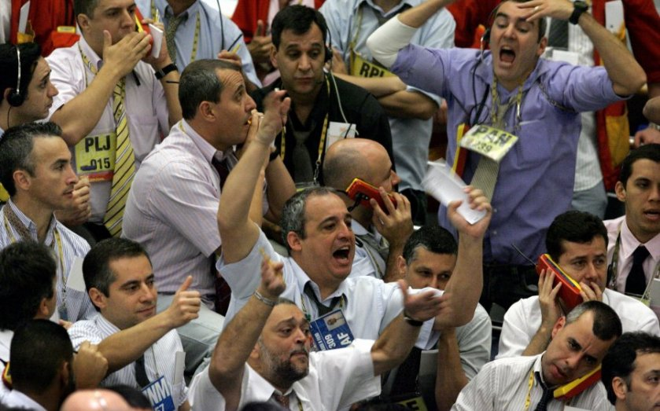

Square Feet 2017
Buy! Buy! Buy!

An Exploration of Ownership Models for
Cultural Organizations in Overheated Real Estate Markets

October 16, 2017
King Street Station

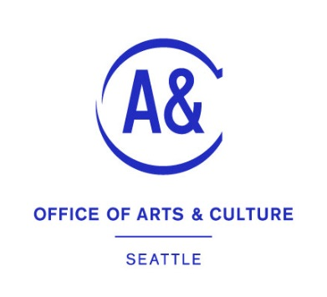

Transcribed, edited, and published
by the Seattle Office of Arts & Culture
February 2018
seattle.gov/arts
Typeset in Seattle Text, the official typeface of the City of Seattle

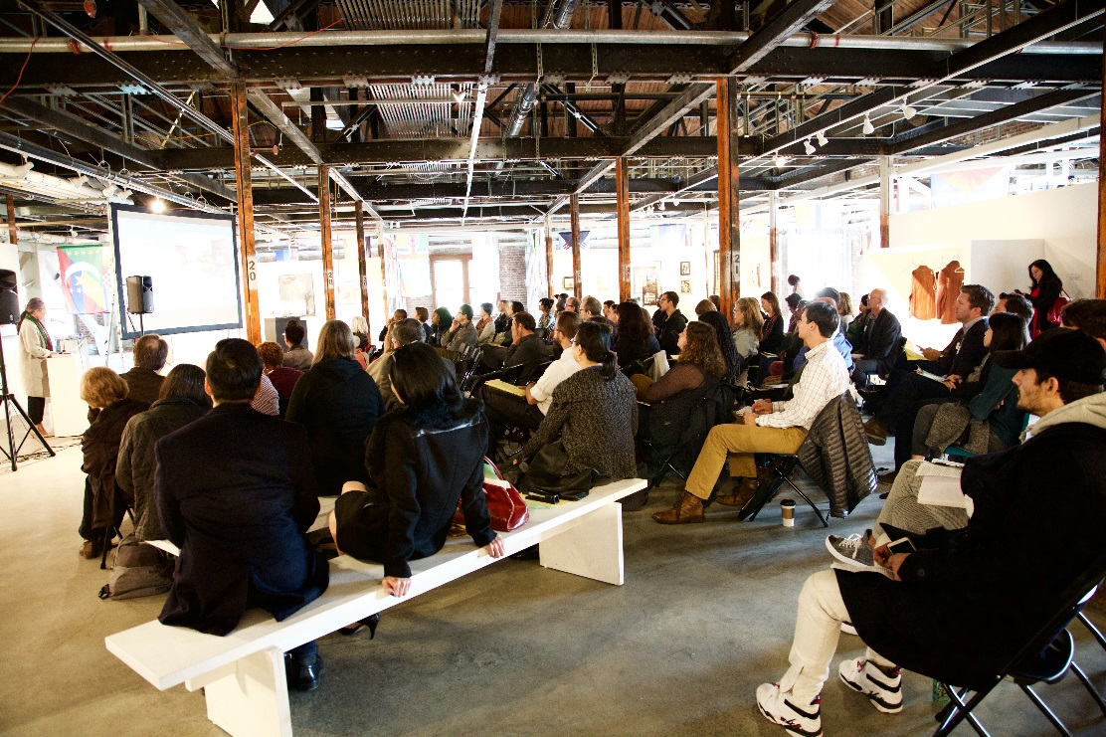

On October 16, 2017, the Office of Arts & Culture, with support from 4Culture, presented the third (roughly) annual Square Feet convening around cultural space issues. This iteration, called Buy! Buy! Buy! explored ownership models and the need of artists and cultural organizations to control their own destiny through the control of real estate.

Over 120 attendees, from up and down the west coast (as far as Canada and California) came to take part in the half-day of activities, presentations, brainstorming sessions, and breakout sessions. What follows is a transcript, and description, of the day’s events.

Presenters:
Cassie Chinn, Wing Luke Museum & Seattle Arts Commission

Moy Eng, Community Arts Stabilization Trust (San Francisco), Keynote Address

Wyking Garrett, Africatown and Michelle Connor, Forterra
Cecile Hansen, Duwamish Tribe (in absentia)
Sam Farrazaino, Equinox Development Unlimited
Uche Okezie, Homesight (Southeast Economic Opportunity Center)

Julie-C, Artists’ Coalition for Equitable Development
Michelle Dunn Marsh, Photographic Center Northwest
Karen Guzak, independent developer
Grace Kim, Schemata Workshop
Miguel Maestas, El Centro de la Raza
Alix Sales, City of Vancouver, BC
Michael Seiwerath, Capitol Hill Housing
Todd Tarbert, Semble

Paper Interactivities

As the attendees came in and mingled, there were a series of paper interactivities on the walls, designed to reflect the group back to itself. People could self-identify in a variety of ways, could add up the cultural square footage they represented, the capital investments they’d made, and more. There were maps and pins to place, and areas to share knowledge gaps and blind spots.
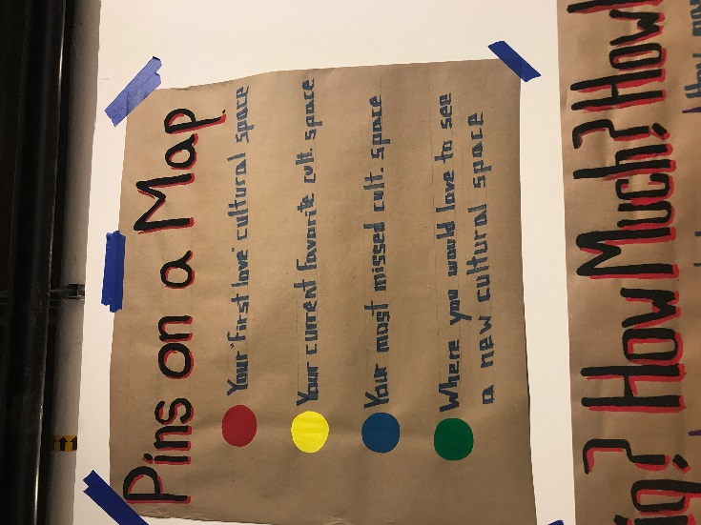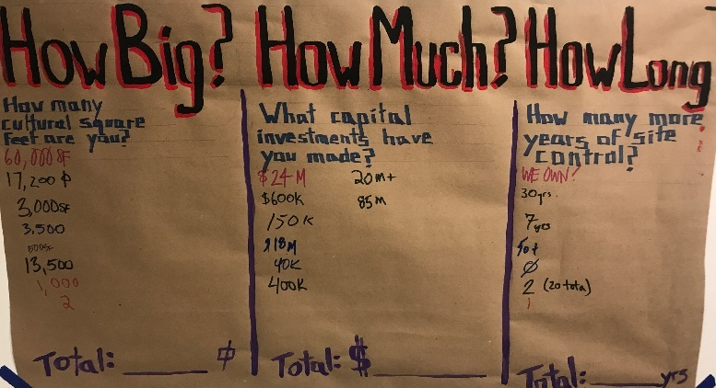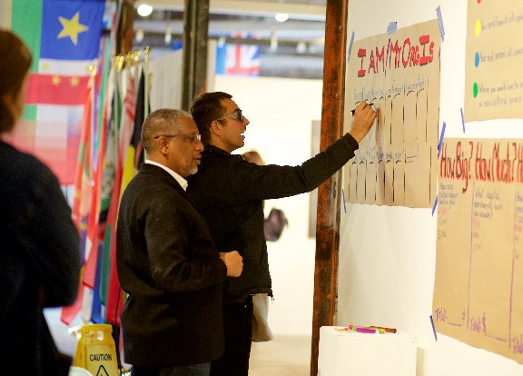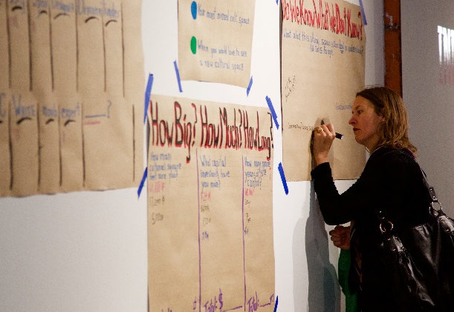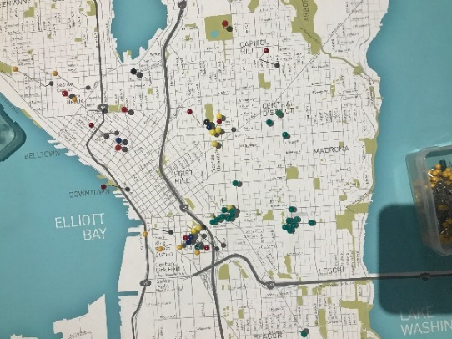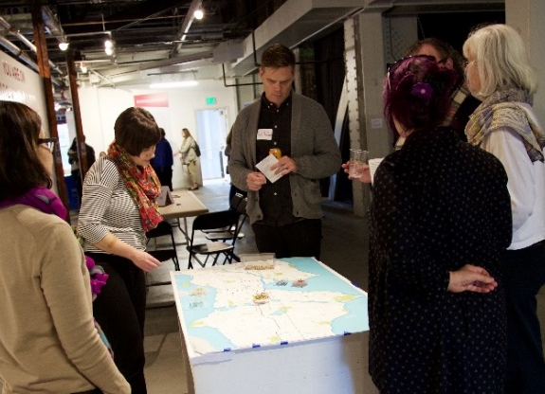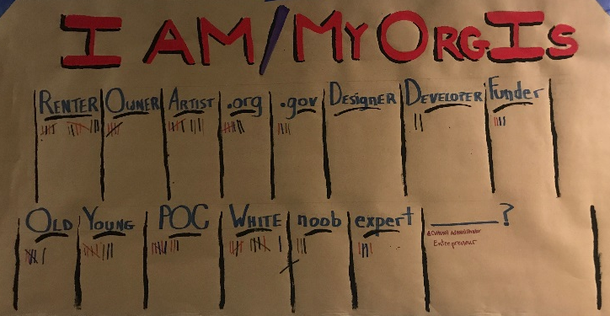
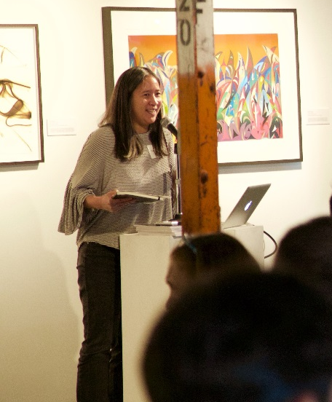
Welcome
Cassie Chinn
Chair, Facilities & Economic Development Committee of
the Seattle Arts Commission
Deputy Director, Wing Luke Museum of the Asian Pacific American Experience

Good afternoon! And welcome!

My name is Cassie Chinn with the Wing Luke Museum. On behalf of the Seattle Arts Commission, I’d like to thank you all for coming this afternoon. And as we begin, we’d like to acknowledge that we are on indigenous lands, especially those of the Coast Salish people.

In putting together this year’s Square Feet program, the theme of inclusion and racial equity were at the forefront of our thoughts. We can’t build the city we want if we don’t center and respect the voices of people of color.

Partnering with the organizations here tonight is one way we are working toward our vision of addressing and working to eliminate institutional racism. Affordability is an issue we all share and by working together we can break down barriers and create the city that we want to live in.

I’d especially like to thank our partner 4Culture for their support, as well as the Seattle Arts Commission and the Facilities and Economic Development Committee and staff of the Office of Arts and Culture for all of your efforts and energies to put this event together.

The theme of this year's gathering couldn't be more timely. It emerges directly from community engagement sessions, including those related to planning for King Street Station, and centers around cultural space ownership in our city. We're excited to learn from the example of San Francisco's Community Arts Stabilization Trust (CAST) through keynote speaker Moy Eng, shine the light on innovative models in our city, and surface future areas for investment through creative dialogue by you all directly.

I truly believe that the conversations that happen here can seed ideas that result in transformational change that can impact the generations to come. As we gather on the edge of the Chinatown-International District, I’m reminded of just such an example that is near and dear to my heart. It was over 100 years ago, and a time of incredible growth in the city yet also a time of exclusion, marginalization and legislated disempowerment. At that time, Chinatown was located in what we know now as Pioneer Square, centered on 2nd and Washington. The community was getting hemmed in. Public works projects were literally cutting through the heart of the community. There wasn’t enough space to support the Chinese American community as the push to build grew up around them.

So what did the community do? I don’t know how the idea came up. Maybe it was a few folks having a conversation around a dinner table, maybe it was at a community meeting where someone spoke up and said how about this idea. But what eventually happened was, 170 Chinese American pioneers pooled their money, formed a corporation where each owned shares, bought land where Chinatown is now and developed two buildings to become the new core of Chinatown. They called their company, the “Kong Yick Investment Company,” with “Kong Yick” translating as “for public benefit.”

It is in that same spirit of innovation, public service and a bit of subversion that I hope we come together today. My great grandfather was a shareholder of the Kong Yick Investment Company. Four generations later, the Kong Yick Company decided to sell one of its buildings to the Wing Luke Museum so their legacy and vision for community could continue.
What eventually happened was, 170 Chinese American pioneers pooled their money, formed a corporation where each owned shares, bought land where Chinatown is now and developed two buildings to become the new core of Chinatown. They called their company, the “Kong Yick Investment Company,” with “Kong Yick” translating as “for public benefit.”
As we listen to the models presented here today and then gather to explore potential ideas for the City to pursue, we can be encouraged and energized that what we do today just might have powerful impacts for future generations.

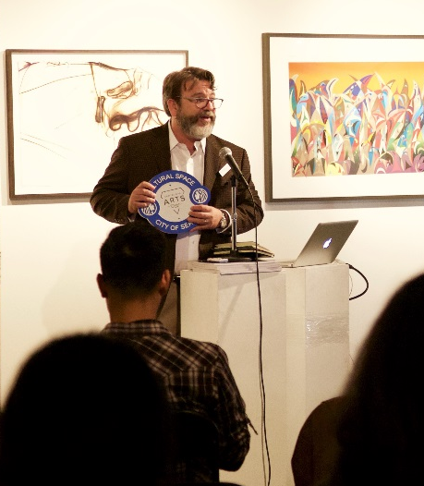
Report to the Community
Matthew Richter
Cultural Space Liaison, Seattle Office of Arts & Culture

Good afternoon, and thank you Cassie, and thank you all for coming. I’m Matthew Richter, I’m the Cultural Space Liaison for the City of Seattle, and it’s my pleasure to update you on some of the work our office has been doing in the arena of cultural space since the last time we met, at the Square Feet 2015 event in South Lake Union.

One of the big things that we’ve done, and that was initiated directly at the first Square Feet event, funded by the first Large Foam Check Challenge, was the creation of this report around the certification of cultural space and the incentives that could accompany that designation. It ended up being called The CAP Report: 30 Ideas for the Creation, Activation, and Preservation of Cultural Space. Leslie Bain, from Framework Creative Placemaking, and her company worked for years on this report, and it’s gorgeous, I have five copies here that I would hand out now except that they’re holding up the microphone.

Of those 30 ideas, I wanted to point out that four of them are now done deals, and we continue to work on the other 26. The first of the four that are completed is the Branding of Cultural Space. This is Seattle’s new Cultural Space Brand, it was originally recommended as part of the CODAC report, and reiterated by the 20 Ideas report. It will first show up in all our Arts & Cultural Districts, and will roll out citywide following that pilot. It’s a wayfinding system, the idea is that instead of making maps or arrows on the tops of poles, we’re taking the “barber pole” as an inspiration and marking the spaces themselves.
The second idea to be acted on is an FAR Exemption and Bonus, that’s Floor to Area Ratio and it basically means that we’re providing an incentive to developers who include cultural space in their projects. You can have more development potential, you can build more square feet into a project if you include a cultural space. This is being piloted in the Uptown neighborhood, and we’ll look at a broader application following that pilot.

We’ve also reclassified how we designate art galleries in the Building Code. Instead of being Assembly spaces, they’re now going to be considered Mercantile spaces. It’s a wonky change, I know, but it means we can now put art galleries into older buildings without refitting the entire building to current seismic, energy, and other codes.

The last is an expansion of the Cultural Facilities Fund, the report recommended an increase in the capital investments that the City makes. The Cultural Facilities Fund is going from $250,000 per year to $1,000,000 next year. Part of what we’ve been doing for the past four months around the idea of that expansion is what we call a Racial Equity Toolkit, to ensure that that expansion happens in an equitable way, that those funds flow to the organizations and the communities that have not been centered in mainstream culture, that have not been invested in over the course of the past decades.

On that note, Mytoan Nguyen-Akbar works in our office and is right over there waiving her hand, and is part of the team that’s doing the Racial Equity Toolkit, and has a survey that she would love for you all to fill out for us as part of that process. And I’ll take that opportunity too to reiterate something that Cassie said, that through all of our funding programs, and through the programming of this space you’re sitting in, and through our public art program, and through all of our programs, the Arts Office views this city through the lens of racial equity and social justice, we take the Race and Social Justice Initiative very seriously, and it informs all of the work of our office.

This [image on screen] is the Capitol Hill Arts District, people watching a movie in Cal Anderson Park. The last time we got together, the group directed the Large Foam Check Challenge to two neighborhoods, to come together and explore their own cultural richness. Those challenges went to two neighborhoods, the Central Area and Uptown (neé Lower Queen Anne). Those neighborhoods used those funds to create events that they leveraged into their own designation as cultural districts, so over the past two years since we got together those two neighborhoods have created the Historic Central Area Arts & Cultural District (which is thriving and has its own space at 23rd and Jackson, called Black Zone), and the Uptown Arts & Cultural Coalition (which was designated by Mayor Burgess just this past Wednesday). The idea of that challenge grant was so good that we made it a permanent part of the process of becoming a cultural district, so any neighborhood interested in moving along that path gets this $2,500 challenge grant, and one was issued this past year t o a south neighborhood, and they now have an application pending with the City to become the next Arts & Cultural District.

Trigger Warning, I’m going to show an image of the Ghostship fire in Oakland. About a year ago a warehouse artspace in Oakland caught fire and 36 people perished during an arts event. A lot of cities around the country responded to that by saying, essentially, to their fire marshals, “if we have a Ghostship in our town, shut it down.” A half-dozen cities around the country lost thriving artspaces that were not up to code and were dangerous spaces. The Seattle Arts Commission and the Seattle Music Commission combined advocacy to the Mayor’s Office to say, “Don’t go in with the wrecking ball, go in with some help. Help these spaces, to the degree that the City can.” The Code Compliance Committee has been active about looking for these spaces and about working with them to come up to current code. Our office has designated two new programs. One is called Safety Boxes, we’re investing in these two literal boxes that Vera Project has created, that contain fire extinguishers, smoke detectors, lit exit signs, all of the things that can make a space safer, so that anyone producing a show can go and literally check out the box the way you check a book out of the library, use it, and return it the next day.

In addition to the Safety Boxes we’ve designated $25,000 to increase safety in these spaces, to conduct needs assessments, and to address some of the most emergent issues immediately, this year.

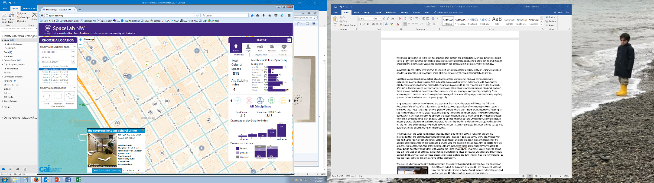
Last time we got together we talked about an inventory we were running, we were obsessively cataloguing every cultural square foot in Seattle. Now, working with 4Culture and with Community Attributes Incorporated we’ve created the SpaceLab NW. I could do ten minutes just on the SpaceLab, it’s a GIS cultural mapping system that captures over 800 cultural spaces, 35 data points about each of those spaces, and about two dozen other data sets that you can lay in on top of it, everything from unemployment rates, to racial demographics, to English as a second language, to obesity rates, anything you would want to know about a given geography.

King Street Station – this is where we are. So a year from now, this space will house the full-time footprint of the Office of Arts & Culture, as well as 12,000 square feet of community cultural space. I warn you that these renderings show a group of people who are far hipper than anyone you’re going to see from our side. Which is great news, this is going to be a much hipper space. These are renderings about what it will look like coming up from the second floor, there’s a lot of visual permeability created to the rest of the building, a lot of glass. Coming up into what we call the Living Room, a social space, a meeting space, a lecture or performance space here in the middle, and then into the space that you’re in, the full-time exhibit space. We could also do an hour just on this project, but I wanted you so see it as part of the body of work we’re coming to today.

This image is of the Large Foam Check that bought this building in 2008. If folks don’t know, it’s interesting that the City bought this building for $10. I include it because as you know today ends with the next Large Foam Check Challenge. Large Foam Check Challenge is about inclusive budgeting, it’s about putting resources on the table and allowing you, the people in this community, to decide how we aim those resources. The goal of the next couple of hours, all of these presentations you’re about to hear, should hopefully spark ideas with you for the Large Foam Check Challenge. You’re going to spend the last hour and a half of today in worktables brainstorming ideas of how we should spend this money, about $8,000. As you listen to these presentations and explore the day, think of it as the raw material, as the gas that’s going to drive the engine of this brainstorm.

The person who’s going to sign that Large Foam Check is my boss Randy Engstrom, he’s the director of the Office of Arts & Culture. Not only would I not have a job without him, the City wouldn’t have a body of work around cultural space, and we for sure wouldn’t be standing in King Street Station.

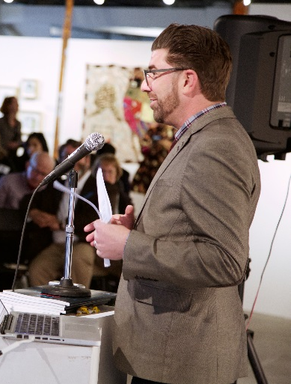
Keynote Introduction
Randy Engstrom
Director, Seattle Office of Arts & Culture

Hi, welcome back, if you’ve been here before, and if not, welcome for the first time. While you’re here please take some time with the exhibition we have here, the Borderlands exhibition, and the And She Persisted show that’s in here, that’s all from the City’s Collection. This is a little bit of what we hope this space holds in its potential for the next 100 years, as we try to anchor arts & culture in this City while we experience all the changes that we’re experiencing.

It’s my pleasure to introduce the keynote speaker who is here, and her name is Moy Eng. Moy is a 30-year veteran of nonprofit management, having worked on the organizational side, the grantmaking side, and as a consultant. She has worked in the arts, on education, renewable energy, LGBTQ+ rights, and international human rights.

She came up through fundraising roles in arts organizations, including Alvin Ailey Dance, before moving to the grantmaking side. Most notably she ran the Arts Program for the Hewlett Foundation.

Before ever coming to the Community Arts Stabilization Trust, which she will tell you about today, she directed resources to create over 750,000 square feet of cultural spaces in the Bay Area ($20mm of capital investments).

It’s easy to bring your out-of-town guest in to sprinkle magic dust over your event, but Moy is the kind of person who really rolls her sleeves up, and she cares about this work, she cares about it personally and it’s not just a gig for her.

She is CAST’s first executive director, which she’s going to tell you a lot about, but I wanted to tell you two personal anecdotes.

I first heard about that project when I saw a presentation that Moy did with my colleague Tom DeCaigny from the San Francisco Arts Commission and others on this model they were building in San Francisco and I’ve never been more impressed with a project that government had anything to do with than I was with CAST. In the most aggressive real estate market in the country, if not North America, they were finding a way to anchor and create permanent affordable space for nonprofit cultural organizations in San Francisco. And if it can work there, I am hopeful and optimistic that it can work in more places.

When I saw Moy today, when we both got to this space, she was like “Oh, October 2014! I totally remember you.” Which I think is a pretty incredible thing, because it was three years ago, and a whole lot has happened in the world in those years.

And I also want to acknowledge how generous with her time she’s been with Matthew and in planning for this event. It’s easy to bring your out-of-town guest in to sprinkle magic dust over your event, but Moy is the kind of person who really rolls her sleeves up, and she cares about this work, she cares about it personally and it’s not just a gig for her. She’s been very generous with her time, we’re happy to have her, and happy for all of you to hear about this model. So please join me in welcoming Moy Eng.

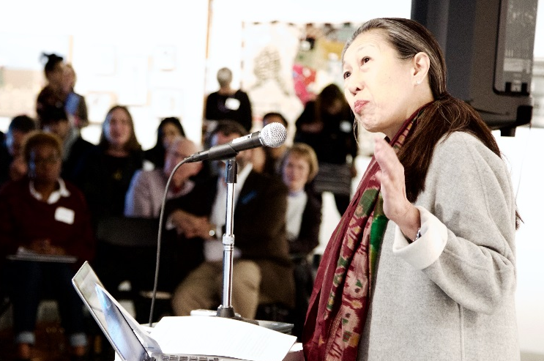
Keynote Address
Moy Eng
Executive Director, Community Arts Stabilization Trust (San Francisco)

Thank you.

I like to do my homework, and because I’m a good Chinese-American student, I always go for extra credit. Matthew asked me, he said “Pose a question for the folks who are coming here to listen and to learn.” So, since I’m Asian-American, I don’t just pose one, I pose three. Ready?

I’d like you to think about this before I start off and chat with you. One: What does “home” look like to you? And you’re going to have to answer this, this will be part of the thread of the conversations we’re going to be having all afternoon. Two: What are the essential key elements in your home? And I mean creatively. And lastly, what would you be willing to contribute regularly for your home?

We’re good? Excellent. So… I’m going to warn you, Matthew said, “Moy, we’d love for you to be the keynote and share your work at CAST.” And I said, “Fantastic, how long do I have to speak?” Because I’m used to zipping through, in like three minutes, seven minutes. And Matthew goes, “Forty-five.” I said, “Only the Dalai Lama deserves 45, and I meant it. So what I’m going to do it shoot for 15 to 18, and what I’d like to do is simply open it up to questions and conversation. Some questions I’ll be able to answer, some will bring up more questions, some of them I can’t answer, but there will be somebody who could. I’m just leaving it open in that way. Shall we start? Cool.

So, you’ve already been introduced, you know my formal title. Executive Director of the Community Arts Stabilization Trust, otherwise known as CAST. But since we don’t really know each other, and even though Randy did this amazing job of digging up things like my sort of lost 4-octave range, I think it’s polite to introduce oneself. So why don’t we start from there.

They say that you are who you are by age seven. And there I am, in front of my church, first holy communion, proud, bright, and wanting very much to make my teachers and my parents proud. What it doesn’t show you is a world that reminded me that I was different. I grew up in a working class industrial town, Trenton New Jersey. A place where men made and built things. Bridges, steel, iron, roads, and even beautiful china. 100,000 people, mostly white, Czechoslovakian, Irish, German. And some “colored folks,” as they used to call African American families then, and two Chinese American families. One of them was mine.

My grandparents and parents were immigrants. For newcomers, who don’t speak English and don’t look like the rest of 1960’s America, silence is a powerful tool. It allows time for you to listen, learn, and be safe.

“My sanctuary was in beauty, in books and in music, and in my twenties, I decided that I would spend my days creating spaces for beauty and possibility.”

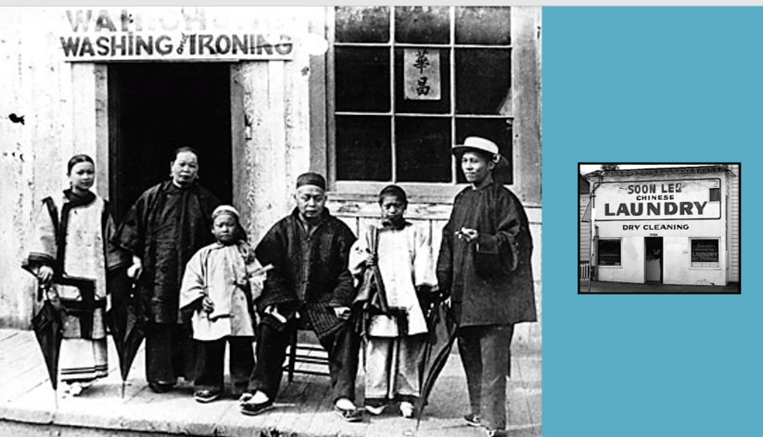
You see, every day someone would stare through the glass window of our laundry, which was painted in red block letters, WAH LEE LAUNDRY. They’d knock hard, and I mean really hard, call us unprincipled names, and do other things to remind me and my family of our place in the world— “Less than.” My sanctuary was in beauty, in books and in music, and in my twenties, I decided that I would spend my days creating spaces for beauty and possibility. With all types of music, from opera to American roots, to rock to blues, everything. So as a hard-core New Yorker, I was seduced by San Francisco’s reputation for innovative and rebellious artists. The third largest population of artists in the US. The first is LA, the second is New York, and then San Francisco. That’s according to an early 2000’s Urban Institute report.

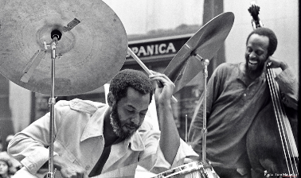
It’s also one of the most beautiful places to live (and you also live in one of the most beautiful place in the US). So for me, with regard to San Francisco, how could I not want to live and work there? So what’s the problem? Artists and small and midsize arts organizations, an integral part of San Francisco’s cultural identity and economy, are being driven out of traditionally marginalized areas of the city due to dramatically increased demand and prices for real estate. The latest surge has pushed prices up so much that rent or a mortgage can easily consume 50% of a person’s salary, and a $3,500 one-bedroom apartment might be easily affordable for an engineer working for a high-tech company, but it isn’t affordable to an artist who may be making a median income of $43,000 a year. Furthermore, the national real estate firm CBRE recently reported that average rents for san Francisco office space have increased every quarter since 2010 and are now 122% higher than just 5 years ago. It found that several years of fast-growing tech-dominated demand simply overwhelmed supply, and resulted in all Bay Area markets becoming the highest in the nation.

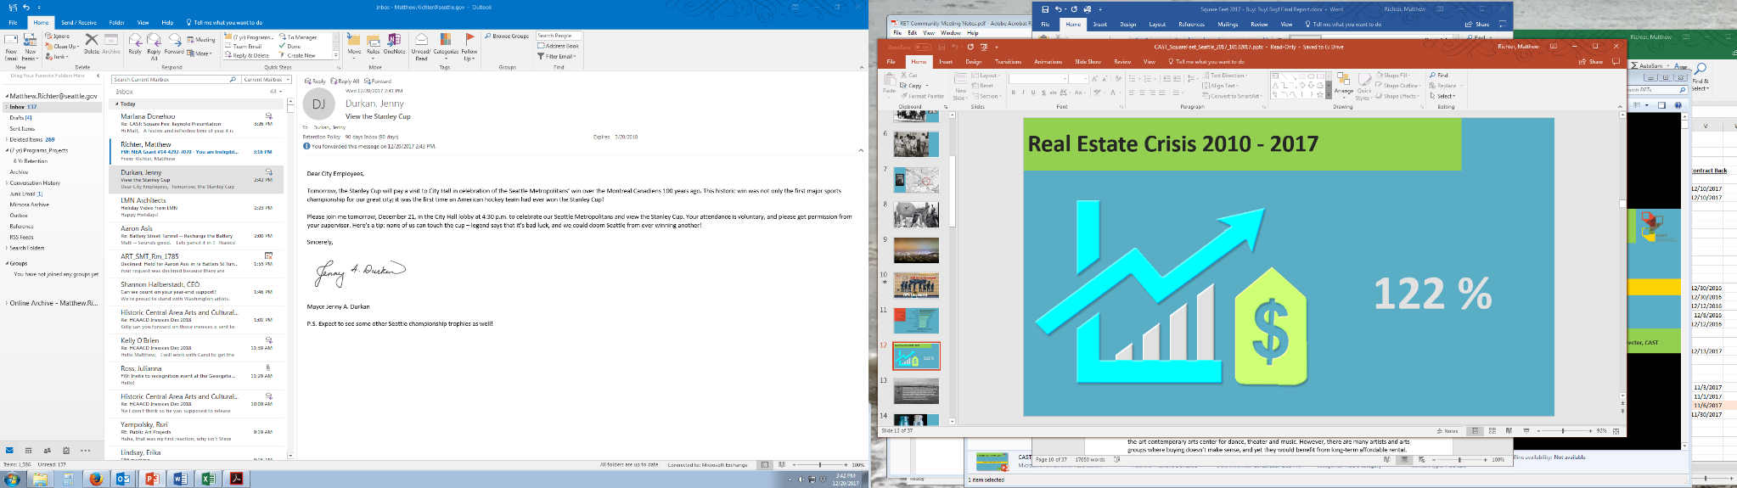
A regional study, The Status of Bay Area Nonprofit Space and Facilities reported that last March that survey respondents identified that ownership of their spaces and working in spaces specifically dedicated to nonprofits would be crucial to weathering the challenges of a Bay Area real estate market. 82% had serious concerns about how this market might affect negatively their long-term financial stability, and 68% think that they will have to make a decision about moving in the next 5 years.

So. We have got to fix this, or else our cities are going to be bereft of art and music, and we’ll lose a key reason for why we’re in our neighborhoods and in our cities. We have a solution. I’m leading an innovative experiment, and I’ll just underline experiment, called Community Arts Stabilization Trust, or CAST. We’re a nonprofit real estate development and holding company. Yeah. I know, it’s an oxymoron, right? We develop safe, affordable, permanent space for the arts in one of the most expensive real estate markets in the country. CAST began during the latest economic surge in San Francisco. A number of public and private sector leaders collaborating on economic and workforce development in central San Francisco posed this question: Might there be a solution that could break the inevitable cycle of displacement for the arts? Not kick the can down the road, but break the cycle. Especially for artists and small and midsize arts organizations.

So they came up with an idea, built on models from affordable housing, community development, and arts & culture. Then these things came into place: A seed investment of $5 million from a foundation that believed in this idea as a new model and its potential to work, and investment in the first project to test it. The second element, a stellar advisory board, that could provide resources, expertise, and stature behind CAST. Let me remind you that CAST was born in January of 2013, so we’re really new. And finally, hiring a staff to execute the model.

So first, can we talk about the model? We’re testing two. The first is an experiment in a lease-to-own model. We buy buildings, offer a below-market-rate lease for seven to ten years to an arts group. We give them time needed to raise the money to buy their home at the price we paid for it seven to ten years before. It also will include a deed restriction on the building, for only arts and culture use. So it stays in the community as a community cultural asset indefinitely. And then CAST recycles the funds to benefit another arts group.

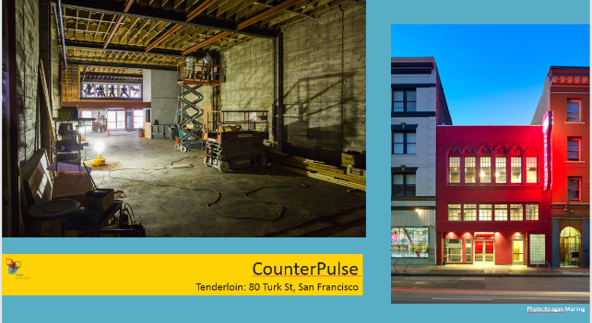
But wait… here we are, our first project. One of our first projects was CounterPulse. With them we rehabbed a rundown, euphemistically “adult” entertainment theater in the Tenderloin into a state-of-the-art contemporary arts center for dance, theater and music. However, there are many artists and arts groups where buying doesn’t make sense, and yet they would benefit from long-term affordable rental. So we’re testing a multitenant model, partnering with a real estate developer on their next project. CAST buys, develops, and manages the building in perpetuity, creating and sustaining a community asset for the long term.

In addition, we also develop initiatives that focus on knowledge-building with our key stakeholders, and address critical time-sensitive issues, such as Keeping Space Oakland, which is a technical assistance and regranting initiative ($600,000) to keep Oakland artists and arts enterprises in Oakland, of which 375,000 will be given out in grants by the end of this year.

And the final tool in our proverbial toolbox: This is the San Francisco version of the SpaceLab Northwest map, which we’ve called the Arts & Culture Assets Map, and this map is intended to provide data needed to preserve our ecosystem and to attract greater visibility to the arts assets as well as contribute to positive and equitable progress.

So.. Who needs to be around the table to make CAST, or this kind of model, work? A diverse group of leaders who provide expertise and credibility, as well as resources.

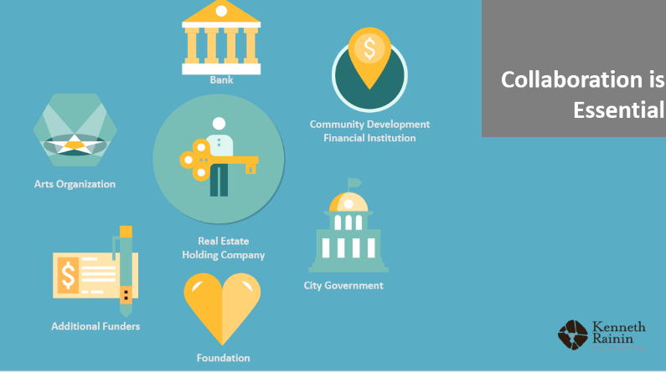

- A real estate holding company or intermediary, and one that can bring expertise, resources, and capacity building, and in this case, it’s CAST.
- Arts organizations, our reason for being, and the focus of our work on creative placemaking and keeping.
- Then we get to Foundations, which bring an understanding of the macro- and the micro-ecosystem and the desire to invest in a space solution or solutions (and of course – shall I be so crass – money). What’s essential is that first gift, or coterie of gifts, to launch a new venture that’s significant enough to fund a first project fully, and large enough to leverage other funders and other investors. A then-new midsize foundation, called the Kenneth Rainin Foundation, based in Oakland, launched CAST with that $5 million and allowed us to buy our first two buildings.
- The next few slides are about the financial institutions – banks, CDFI’s, the City government, and other funders, all of which bring, again, expertise, capital, and in the case of City Government, they can play multiple roles, and we’ve seen that just in some of the things that Matt talked about earlier, from funding to making the case for the community value of the arts and nonprofits, to identifying properties that could be cultural spaces, to affecting in a positive way zooming, regulations, incentives and policy-related matters.
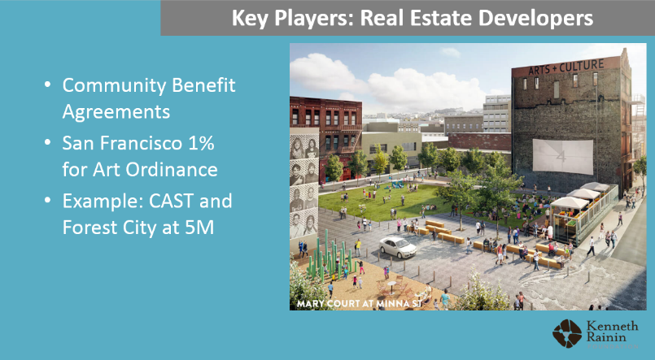
- And perhaps the surprise, real estate developers. In San Francisco, if a real estate developer is building a new building or a set of buildings, there is a 1% For the Arts ordinance, as well as community benefit agreements. So as part of the 5M Project, a four-acre mixed-use site (and if any of you have been to SF, it’s at 5th and Mission, right where the Chronicle Building is). And if you see there on the right, that brick building where it says Arts & Culture? The developer is contributing that 12,000 square foot building, as well as a cash contribution towards the development of a multitenant arts building by CAST.
- And lastly, staff to execute. CAST wasn’t actually intended to be a nonprofit. It was indented as a one-time experiment and a test. Except, the issue was so urgent and so great, the board decided to launch CAST as an ongoing nonprofit to really focus on long-term solutions. So we now have a full-time staff of five, supplemented by part time staff and consultants.

Now, those are the components.

So where are we now? In four short years, we bought and opened two arts buildings, in central San Francisco for two arts groups, and through their programs will serve 95,000 people per year, and that’s one out of eight San Franciscans. We’ve already attracted exceptional public and private sector support, and we’ve been acclaimed as a model in publications by the Federal Reserve Bank in San Francisco, LISC, and the World Cities Culture Forum.

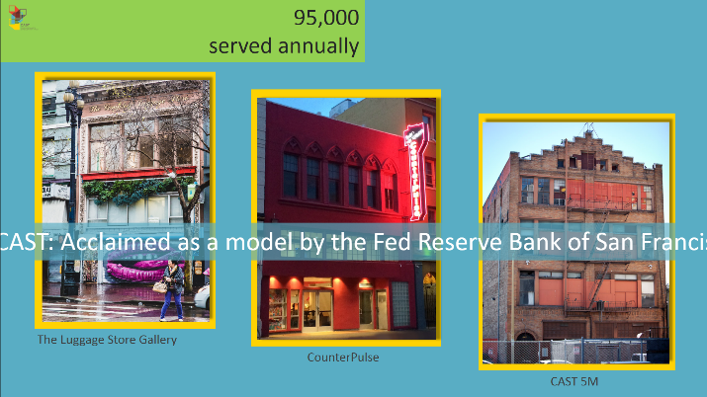
What’s next? Over the next decade, we aim to raise approximately $100 million to acquire approximately 100,000 square feet in San Francisco and in Oakland. We have already $24.1 million in-hand, another $25 million in the pipeline and are on target to meet our goal with our next three projects that are in our development pipeline. (That’s where I get all the white hair, just sayin’.)

So, what have we learned? New ventures, and you know, if you’ve done VC work or done and developed new work, these bullets will look familiar to you, that anytime you do new ideas, new ventures, things that don’t really have a precedent, even if they don’t look familiar, they require time, money, agility, honesty, patience, and almost always, even if you’re smart and you’ve don’t this before, it takes more time and more money than you expect. And often with time, it takes two times, three times, four times, even with the best possible planning and expertise. Mistakes get made – and this is where the clear-eyed honesty part comes up… You do this as artists. Could those who are practicing artists raise their hands? Okay, you know when you’re creating work, if it’s not working, you change it up, and you identify what you need to do, and I think in this case, the same thing, even when you know that there’s so much potential, more than anything because of the responsibility, you have to pay attention to the mistakes.

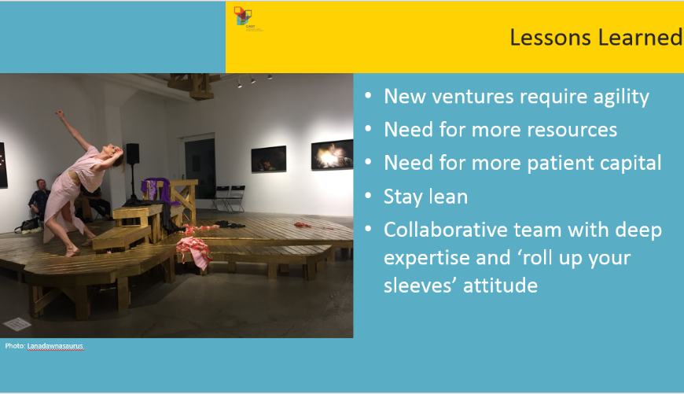

And I’ll just share with you one mistake we made out of the best of intentions. One of our founding board members shared and said, “Matt, the theater that you’re in, we’re going to promise you that when you move into your new space, with triple the square feet, you will pay the exact same amount.” Okay, you know what the punch line is, right? Shall I drop the other shoe? The cost, even with philanthropic support, and new market tax credits, it’s not covering the mortgage. So, CAST is paying that expensive lesson, and what we’re doing is we’re honoring it, because we said we would, but we’re not doing that again. And I’m not using the word “never,” we’re just not going to do that again.

Real estate requires lots of capital. I know, that’s a “duh,” but when you’re used to running an arts organization, the core work that you do is typically, even when there’s a sequence, there’s an organic quality and an intuitive quality generally. With real estate, both in the purchase, and the execution and managing it, it is very sequenced and required a great deal of capital. And so, if you’re going to be poised to take advantage of an opportunity, you have to raise a fair amount of money or at least have access to capital and people who believe in you.

Staying lean and smart: We’re right now looking at “What’s the size and scale of staff we need in order to support the work that we ultimately will do and seed,” because there’s such a long timeframe to actually start from a seed of an idea, to a space, to actually the ribbon-cutting, in San Francisco can take from three to 20 years. Yes, I said 20. So it’s a long arc.

Not too discouraged yet? Okay.

And then there’s a need of philanthropic capital for the core staff, and for the work that you’re doing because of that long timeframe.

So what are we grappling with? Here are some questions.

- How do we select projects? We focus on long-term impact. Unless there is some urgency, time sensitivity, and we can address either short or intermediate term, and in the case that you saw with Keeping Space Oakland, that made sense for us to enter the fray, and we had the right expertise, and we were invited.
- How do we work with our long-term arts partners, and arts tenants? We learn from those who have done it, like our colleagues at the San Francisco Arts Commission and at Tannery Arts Center, which is a joint venture with ArtSpace.
- How do we work with them when we end up having buildings? We meet them where they are. And we add value through high-touch customized technical assistance and services.
- One question we’ve gotten since I walked in the door on June ‘14, is “This is so exciting, you’re focused on permanent space? Will you come work in our city?” Which is great, it’s always lovely to be wanted, so what I will say to you is to answer in two ways. One is that real estate depends a great deal on deep local knowledge and relationships. And while there’s interest from across the US, we only go where and when CAST is invited and when we can fulfill a singular, distinctive role that cannot be filled locally. We do not want to be seen as, and we do not act as, carpetbaggers, taking resources out of a community instead of bringing a value-added relationship. And, certain contributing factors have to be in play: Money, public and private sector leadership, and that there may be a potential arts and culture project that could benefit the local community for the long term. And all those factors were in play in Oakland, and that led to Keeping Space Oakland.

Outside of the Bay Area, while we’ve been approached by public and private sector leaders in Denver, New York, Boston, Minneapolis, Nairobi, London, and that’s only a few, given our youth and high demand (and I was Employee #1 for the first two years), we shared our efforts, our emergent model, and shared mistakes and questions and began a more formal and informal conversation with leaders from across these cities. I should share with you that the city of London, while we do not have a formal consulting relationship with them, we have been in touch, and they are currently in the midst of creating a creative land trust, to secure permanent, affordable, creative studios. This is inspired by CAST, with bridge financing for artists and creative enterprises to buy their own studios in London.
“At the end of the day, our work is really about developing equitable progress and development in our cities. This is one strategy that does that. How do we demonstrate it? We’re collecting that data through our work with Keeping Space Oakland. I’ll come back in three years and I’ll tell you.”

What about housing? In an expensive place… We believe it’s essential and critical to solve this issue. However, we have chosen to stay in our lane, and that is workspace, long-term, for arts and culture, and we’d be open, because we think we have to solve that part of the equation, with an experienced partner in affordable housing. And we would say the same in the social services sector, where we have also been pulled in.

As I said, this is only one way, this is where we began at the top of this 15 to 18 minutes… We’re not alone. There are others working on keeping space and keeping artists in cities, including The Minneapolis-based ArtSpace, which began creating live/work spaces for artists in 1979, and which now has 20 locations across the US, including, as you know, Seattle. Internationally, London is even more expensive. I mentioned London earlier, this is Sommerset House, and the City of London has lead the effort to convert this 500,000-square-foot building, which is a former palace, to a public cultural center.

So it takes a village, locally and globally to make this happen, and CAST, we, are well on our way to keeping San Francisco innovative, wild, and wonderful. I am thrilled to be leading CAST and this experiment, and am happy to open it up to questions.

Question: If you’re selling the building after 10 years to the partner organization at the cost you paid ten years prior, how are you and your staff supported? Are you using the lease money to pay salaries?
Moy Eng: No. I’ve been working in the nonprofit cultural sector since 1979. I know, that’s a long time ago. And I feel lucky about it. I’ve been able to work as a philanthropoid, as a director of development, for the Ford Foundation, the Mellon Foundation, blah blah blah… So I just want to frame that. So my viewpoint was that we needed to raise three to five years of philanthropic dollars so that one, we would be able to hire a team. It would keep the rent low, there would be no impact on the rent. And that is actually a strategy I continue to use as I look out at the next 100,000 square feet. Have philanthropy make a deep dent on this. What happens is if you drive it with philanthropy, then it lowers the cost at the long-term end for artists and arts organizations.

Q: I’m curious about the social impact that you’re making. Can you talk about some of the indicators that speak to the social impact you’re having? Well-being, social cohesion, rooted in equity and justice, education, youth development, that then could potentially lead to other social impacts?
ME: Fantastic question, and I will share with you that that gets to selection criteria, who we wind up working with, in terms of arts partners as well as arts tenants, and that’s evolving, as I mentioned to you earlier, how do we select, and it’s critical to put a racial and social justice lens on all of the work that we do. At the end of the day, our work is really about developing equitable progress and development in our cities. This is one strategy that does that. How do we demonstrate it? Ask me in three years. We’re actually collecting that data now. We’re collecting that data through our work with Keeping Space Oakland. I’ll come back in three years and I’ll tell you.

Q: Question about the money (it’s all about the money). Is it all grant money to buy the properties? Or is it social impact investing, are you leveraging with debt?
ME: It is not all about the money, although the money is one piece, and a very important piece. At this moment, what we’re doing is I’m spending a whole lot of time raising a whole lot of philanthropic dollars, as much as I possibly can. Again, it’s about the long-term view of getting poised, getting ready to support artists and arts organizations and that’s the first piece. At this moment, just to give you a sense of it, we’ve raised $24.1 million in three and a half years. Of the $24.1 million, $2.3 million is from new market tax credits, and who owns those tax credits and manages them, it’s a CDFI and JP Morgan Chase. The rest of it’s all philanthropy. Go figure. So the rest $20 to $25 million in the pipeline is a combination of philanthropy and deals that I’m cutting with real estate developers, which are, again, philanthropic dollars.

Q: Foundations are moving more funds towards education I’m curious about which types of foundations you’re getting involved with for funding, and how they respond to your successes, and what types of experiences you’re having with foundations.
ME: We’re privileged in a couple of ways. The five founding board members who we started out with including two from the Rainin Foundation, which came up with the $5 million, have a stature in the community and a reputation for knowledge in real estate development, construction management, community development, affordable housing, as well as philanthropy. So they gave an imprimatur by virtue of them rolling up their sleeves, and they did, become super-staff for CAST until I stepped in the door 18 months later. When you have a lead foundation in a particular region—and in the San Francisco Bay area that’s Hewlett and Irvine -- I think you have to start with “who are the leading foundations,” and “what’s the size and scale of their grantmaking.” I felt like the decisions I made were about “where can I get the most money for the fewest grant applications?” That may sound crass, but it’s just strategic. If I wasn’t looking at at least a low-seven-figure grant, I would pass and work through those first.

What I thought was really critical, especially when it was a staff of one, was to really move our base on the potential and the momentum of this idea. In order to make this possible I had to light a fire in order to make it look real. We had to finish the financing and the funding, we had to get a staff in, we had to raise enough money to create a pipeline of projects, to get to scale, so that we could really provide some sense of impact for the mission. So I focused on the largest foundations, the largest grants, in the quickest amount of time. For both capital and for operations. This is grantwriting 101, if not 201, do your homework, start out with the ones who are the most influential, largest grants, interested, understand the importance of space, and in this case, believe in the potential of the idea. Being sophisticated and having an impact. And if you can do that… that’s why I’m sitting on $24.1 million at this point.

Q: How often do you say “no” and “yes”? What’s your ratio of taking on projects?
ME: Roughly? I usually have a pipeline of anywhere from $300,000 to $500,000, that I’m in conversation with. Probably it’s one to two out of town, these days. So one of the elements is size and scale, impact, term, is it permanent, can I get a 55 to 100 year lease? I figure 50 years is not bad, right? So I look at term, and then how many artists and arts organizations can a project serve?

Thank you, I’m so delighted to be up here, thank you to the Office of Arts & Culture, it’s an honor to be up here.

Four Local Presentations

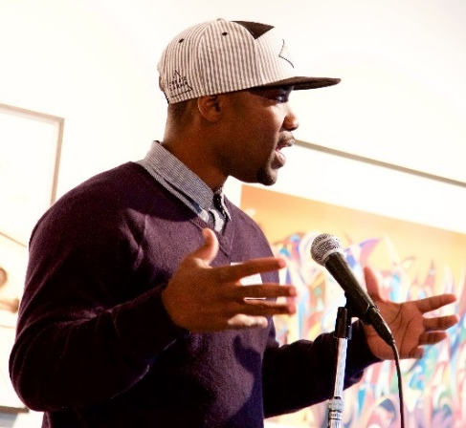
Africatown at Midtown Centre
K. Wyking Garrett
Director, Africatown Seattle
Michelle Connor
Forterra

Wyking Garrett: Good afternoon, how’s everyone doing? I’m Wyking Garrett, and thanks for having us here to talk about this particular project. I’m here representing Africatown. We’re going to talk about the Midtown Project.

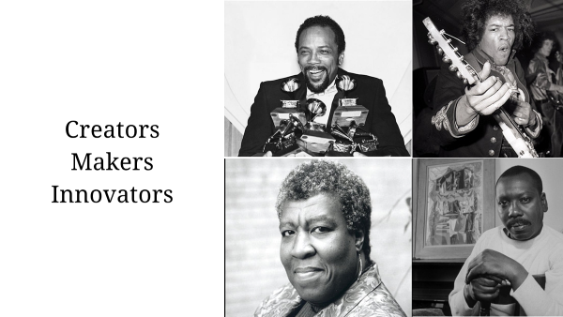
So we know that the black community has been in Seattle for at least 130 years. The very first black resident documented is Manuel Lopez from Cape Verde, a barber and a musician, so he was a creative entrepreneur. He was followed by pioneers such as William Grose, who bought 12 acres of land from Henry Yesler, and made the Central District a settling place for black people in 1882. Larger migrations happened around World War II in the 1940s, when housing covenants limited where blacks could rent, own, live, and the Central District was that place, and it produced, despite the negative or hostile environment, it produced a rich cultural environment, it produced people such as Quincy Jones, Jimmy Hendrix, Octavia Butler, Ernestine Anderson, James Washington Jr, and many others, up to people like Ishmael Butler, Tendai Maraire, and the many others who are doing things that originated in the community. We know that for many years the community still suffered under redlining, white flight, divestment, and many public and private policy practices that limited the growth and full realization of the economic potential of the African American community in the Central District.

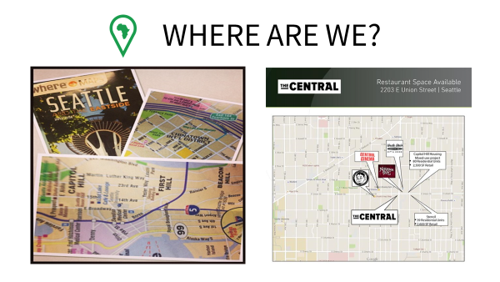
That was followed by the influx of drugs, followed by mass incarceration due to policies such as “Weed and Seed” which started here in Seattle, in 1992, and now 25 years later we can pretty much clearly see who was identified as the “weeds” and who were identified as “seeds.” Even now, to this day, if you get off at the airport or if you come on a cruise line, and you pick up a tourist brochure, you’ll see Capitol Hill, First Hill, Chinatown / International District, but you will not see Central District or Africatown, even though this is the community that gave, really, a soul to this city, through its creative energy and its struggles for human rights and social justice. On the other side, you see an advertisement for commercial property that was up for rent in a building at 23rd and Union, and the only businesses that you see highlighted are new businesses that cater… it doesn’t highlight the legacy businesses that have been in the community such as Earl’s barbershop, and many of the east African restaurants, and Home of Good BBQ, and many of the institutions that have been in the community for a long time. So just the idea of “erasure,” and “do black lives matter,” and we see, time and time again, statements to the contrary.
And so we ask the question, “where are we,” and we took a cue from our brothers and sisters right here in Chinatown / International District and Little Saigon, and we see that not only here, but throughout the world really, wherever there is a community of Chinese people there is a Chinatown, a direct link back to their motherland, or homeland, and even here we have New Hampshire, New Orleans, New England, so there’s a clear connection that people were somewhere before they came to this space, they had culture.

So we answer that question with a very affirmative statement that we are here, not only as we’ve been in this particular neighborhood or city for 100+ years, but as we came to the western hemisphere as Africans, with culture, with identity, so we embrace all of the African diaspora, the Caribbean, afro-Brazilian, Afro-Latino, African, African-Asian, European, and we encompass that within the concept of Africatown, which is an asset-based community development initiative. So it’s really about highlighting, and uplifting, the fact that our culture has brought value, and many are capturing that value. Starbucks has built a billion-dollar global enterprise off a piece of African culture, the Ethiopian coffee ceremony. And so again, we’re looking at how do we lift that up and capture that so that it benefits our community, those African people that originated this culture.
It’s really about highlighting, and uplifting, the fact that our culture has brought value, and many are capturing that value. Starbucks has built a billion-dollar global enterprise off a piece of African culture, the Ethiopian coffee ceremony. We’re looking at how do we lift that up and capture that so that it benefits our community, so that it benefits those African people that originated this culture.
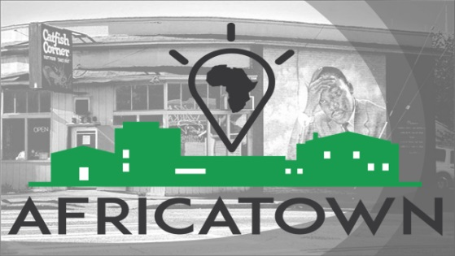
You look around, and is the sea hawk the official bird of Seattle or is the crane the crane the official bird of Seattle? We see the cranes everywhere but we do not see things being built for everyone. If you’re going to have a world-class city, then it should be inclusive of the communities of the world that have been here. I looked at the Seattle 2035 plan, and I did not see our community, I did not see my two sons, in that plan. And so we went about the business of making our own plan, and writing ourselves into a future that we had written out, or left out, or whatever the case may be. We went out and we had Imagine Africatown and we gathered ideas from within our community and the broader community about what people wanted to see in a community that represented the best of our black experience here and the African diaspora abroad, and how would that show up. And we came up with the concept of a cultural innovation zone. And we knew that through this work the central district has now been identified as the second Historic Arts and Cultural District. Now, we did not just want to become museum pieces, amenities for a New Community in terms of just having markers, Jimi Hendrix played his guitar here, and James Washington Jr. Lived here, and Ernestine Anderson, you know, sang on this corner, but we figured that people being able to carry on that legacy is the greatest honor to that legacy. We also understand that innovation districts are also about the economy, and cultural arts are often thought of as an amenity even though we know they are economic drivers, too. But many times we know that those artists don’t get to benefit from the economics that they drive.
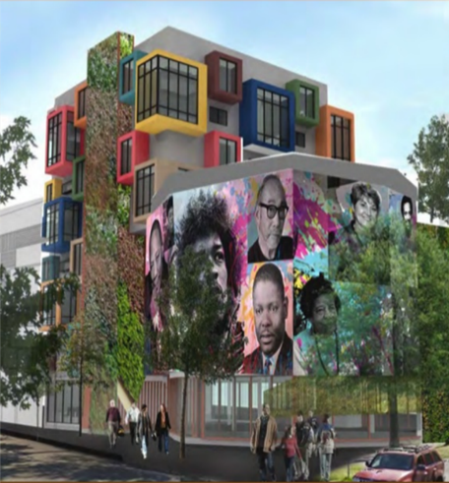
So we thought that a cultural innovation zone, where the legacy of innovation from our communities such as what Jimi Hendrix did with the guitar, hip-hop, and the ongoing legacy of innovation coming out of our community, but it’s currently disconnected from the innovation and startup economy that’s around us so we wanted to connect that, so that’s what we envisioned, and so that’s why we envisioned the repurposing of Fire Station 6 as an innovation hub, and we’ve been working on Midtown Center, and this was the largest piece of real estate in the community that was going to the market, and these are conceptual designs done by a studio led by Dr. Sharon Sutton, at the University of Washington, which explored Afrocentric design principles and what is unique about that. And we took that as inspiration, and what does it mean to have a build environment that actually reflects our values, the way we live, and things of that nature. We created an innovation hub, a pop-up called Black Dot to bring together creatives, technologists, and community members to really innovate and think about “how do we hack gentrification,” how do we disrupt displacement, and came to the conclusion, as jay-z said, ‘til you own your own you can’t be free.” So we had to figure out, how do we apply that? How do we get ownership?
The Liberty Bank building was the first project that embodied the Africatown principles around identity and ownership. We were able to develop a very unique MOU with Capitol Hill Housing, the Black Community Impact Alliance, and Centerstone, and that is coming to light. We broke ground on Juneteenth, and if you drive by 24th and Union now you’ll see construction happening. And why stop there? That was in June, and along the way we had a serious opportunity taking place around Midtown, with partners Doris Koo and the Yesler Community Collaborative connecting us with Forterra and bringing their expertise in the space of land banking, primarily greenspaces, but bringing that into an urban context and seeing the midtown center as an opportunity.
I’ll let Michelle speak about that, but I wanted to say that that article about the vanishing black community was published in May of 2016. This article is almost a year to the day, May 23, 2017 and speaks to Africatown striking the deal that created the opportunity [drowned out by applause]…

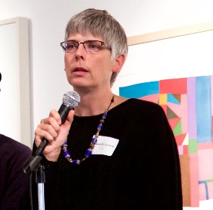
Michelle Connor: Forterra started out as a land trust, in the environmental movement, and many of you who follow urban issues know that there’s been a gap between environmental issues and the needs of urban communities. And it’s been a gap that the environmental community has aspired to hurdle, and I think folks like Wyking have said, “where have you been? We need you.”
For our organization, having started 25 years ago, our work has been voluntary real estate transactions, where we’ve had to cobble together money to help to preserve farmland, to help to preserve old growth, to finance working forest lands. We’ve bought working railroads, we’ve bought small mines, we’ve bought small cottages that have then become p-patches, and this seemed like a natural extension for us. And the issue and the question is, “how to you find the money to make it happen? How do you find the money to hold land on an interim basis? How do you find the capital to make it affordable to the uses that benefit the community? And how does the community afford to sustain it itself?”
The stretch for us was making the bridge from thinking about old growth and parks to thinking about places where people thrive. If you think about ecosystem services, who owns the land determines how it’s managed, determines how the benefits are distributed. It’s the same in the urban space. It’s something that I think Moy just captured really well, which is, “If we control the land, we can determine how it’s managed and we can get public health and community benefits from that.” Why should an organization like Wyking’s, or an arts organization, or a church, or a community who’s struggling with the basic issues of the day to create opportunities for their families, why should they have to have a back real estate office? They shouldn’t have to.
So it was really natural for Forterra to say, “Okay, that’s something we can step into,” and to look to Africatown to guide us both as to the benefits that can come from the project, how we embark on the project. I think that one of the most powerful things that Africatown brought to this table was a set of principles. And having a set of principles about what you can say yes to is incredibly powerful. If all you can do is say “No,” you could have success looking you in the eye and you wouldn’t know it.
The stretch for us was making the bridge from thinking about old growth and parks to thinking about places where people thrive. If you think about ecosystem services, who owns the land determines how it’s managed, determines how the benefits are distributed. It’s the same in the urban space. If we control the land, we can determine how it’s managed and we can get public health and community benefits from that.
With those standards, Wyking held everybody to a really high bar, and got everybody to accomplish what we all thought early on really was not possible. So in thinking about your work, spend some time on the question, “what are your principles? And how do they translate into economics for developers?”
When I started on this project, I think the day we met, the news broke that Lennar Regency had gotten site control, and so when we were meeting, it was to explore how in the world could we get site control of a 2.5 acre property that was worth, call it $23, $24, $25 million? It was probably one of the most competed properties in all of the city. But this property needed an upzone. And that was the key to the position that Africatown had. Because they had principles under which they could support an upzone and get the community to support an upzone, and if those principles were honored, then that created a negotiation platform with the developers.
I think that one of the most powerful things that Africatown brought to this table was a set of principles. And having a set of principles about what you can say “Yes” to is incredibly powerful. If all you can do is say “No,” you could have success looking you in the eye and you wouldn’t know it.
And so Lennar Regency, for those of you who aren’t familiar with this, they wanted to put a 30,000 square foot grocery on the property, deck it out on top of affordable housing, and we went to their land use attorney and to the developers, and we said, we want a half an acre of this land, to purchase, for the community to hold and develop and use as they see fit. That was a shock to the system for the developer, they didn’t expect that. But they engaged in a dialogue, and the Africatown Community Land Trust was active in that, and that was a moment of learning for me, (thinking about what were the lessons learned for us, a traditionally white-lead environmentalist group working with a historically underrepresented group) one of the things I didn’t appreciate was, when working with communities, and we’ve been doing this for an awfully long time, the community’s our client, and we go sit at the table and we hammer out the deal, and we come back, and we say “This is the best we could do,” and the community says okay, or no, and I say, “Are you sure? You really want to say no to that? Because this is your chance…” and ultimately I have to defer to the community.
What was different in this case was how important it was to have a voice and to actually be at the table. And that wasn’t something that I fully understood at the time. And I learned a lot. And I think we got more, because of the commitment and the dedication and the skin in the game that the community had for what happened on this property. So yes, there’s a place for professional support, but the thing that bothered me during all of that was that the least resourced group didn’t have paid staff sitting at the table, they were doing it on the side of all their other obligations and commitments. And so to me these guys are really heroes.
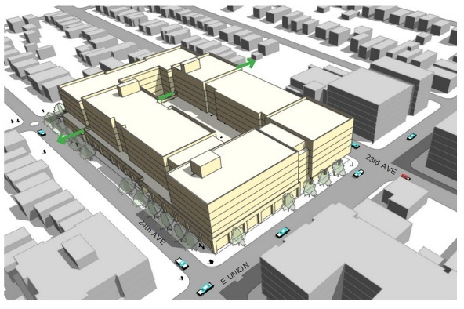
So, we lost the Lennar Regency deal when the community rejected the scale of the project, they walked away from the contract. At that point we put our heads together with Doris and talked to one of those partners, and said, “if we get site control, if we get money that’s at risk, would you be willing to buy a portion of it, and I mean like ¾ of it,” and they said, “sure,” but they wouldn’t commit to it. So we put in our offer, we put our hat in the ring, and that didn’t work out. Then we knew somebody had site control, but we didn’t know who. That’s when I was able to use some of our relationships to sort of go back door to ask somebody for a conversation, and then we all sat down, and I think I might turn it over to Wyking to talk about the principles he brought to the table, and leading us through “what constituted a win.”

Wyking Garrett: So, in the process of figuring out the ownership piece, we formed a community land trust. We decided that was the best vehicle to facilitate what we were trying to do, to create long-term affordability and community benefit. I also need to say that the City played a role in the process too, from the Mayor’s Office to the Office of Economic Development, in terms of bringing people to the table to work things out. So just in terms of understanding each player in the game, each piece has its own leverages and strengths. Our basic framework for partnering on development, what we created was we created a rubric to measure how we’re doing. And for us, when you say, “equitable development,” the key there is “equity,” and in this context, equity means ownership. So that’s the first thing. Who owns what. And then the next thing is, in development these are $30 million, $40 million projects, how are those resources being distributed from the time there’s a legal transaction, or surveying, to predevelopment, to design, to temporary uses of the space, a pop-up in a building or a community garden, to design, who’s the architect, who’s the general contractor, and on and on… And then decision-making, who has the agency, who’s making decisions about what’s happening, and how is that shared? These are the things we go through to measure our success.
You know, many times I’ve found that people think that talking about the problem is solving the problem. But the actual outcomes are measurable in terms of quantities of dollars and cents, and square feet, right? So that’s what we’re going to measure, at the end, to know, how much did we win? How much progress did we make?
So we got 20% of the land, and then we also brought in Capitol Hill Housing to complete the transaction around the affordable housing development.
So we’ll measure who gets what our of the deal, and who gets to realize their vision and input into the project? And then who gets to use the space once it’s built? Who builds the space, and then who gets access to the space as far as residential, commercial, and then how does the space, how does the building actually come alive in the community in the context of our values around preserving and developing the legacy of the black community the African diaspora in the central district in Seattle? So that would be the long-term, right? And then there would be the ongoing benefits around who’s managing, and who’s got the maintenance contracts? So we’re very… you know, many times I’ve found that people think that talking about the problem is solving the problem. But the actual outcomes are measurable in terms of quantities of dollars and cents, and square feet, right? So that’s what we’re going to measure, at the end, to know, how much did we win? How much progress did we make?
So thanks to everyone who participated. We think that we made progress from Liberty Bank to Midtown Center, and these are models to be iterated on, improved upon for more and more community benefit, so solutions have to continuously be innovated. Thank you for having us.

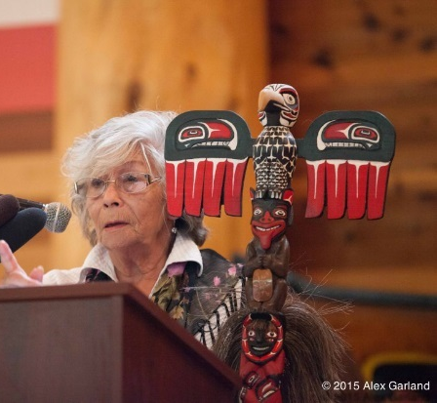
The Duwamish Longhouse
Cecile Hansen
Chair of the Duwamish Tribe

Matthew Richter: Our next scheduled speaker was to be Cecile Hansen, but when we started the program today Cecile hadn’t made it into the room yet, is Cecile here? No? Okay, I’d like to say a couple of words about Cecile’s work, just to put her, and to put the Duwamish Longhouse, on your radars.
Cecile is the great-great-grand-niece of Chief Si’ahl, from whom we took this City’s name. She took over as the chair of the Duwamish Tribe in 1975, and one of the very first things she did was create a small cultural space for the Duwamish. It was a small storefront next to a McDonalds in Burien. She leveraged that space into a next space, and a next, and a next, and they were a little nicer and a little larger each time. And finally, she had gotten the tribe into a small stand-alone cottage down by the Duwamish river, an old home, and they then leveraged that into the ownership of the industrial property next door, and in I believe 2008 they cut the ribbon on the Duwamish Longhouse Cultural Center, which if you haven’t been down to it is a gigantic and gorgeous cultural space on one of Seattle’ worst roads ever, it’s just a dangerous and ugly nightmare.
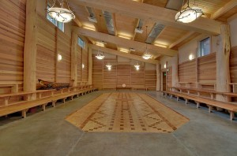
But the space itself is a warm and lovely home for the tribe and the community, and I say “tribe,” but the Duwamish have been denied tribal recognition by the federal government for over 100 years. When we opened our event today by acknowledging (as we do at the Office of Arts & Culture at any event we host) that we are on tribal land, that we are on the traditional lands of the Duwamish people, we mean that we are on Cecile’s land. That’s who we’re talking about. So we hope that she’s alright [she was] and if she does show up we’ll include her presentation then, and in the meantime I encourage all of you to visit, explore, and support the Duwamish Longhouse.

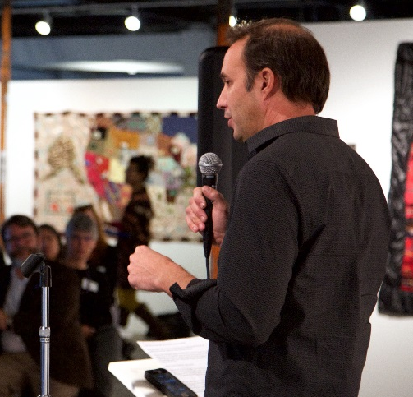
Equinox Studios
Sam Farrazaino
Developer & Owner, Equinox Studios

I am Sam Farrazaino, and I’m here to tell you today that I have failed. For the last 30 years, I’ve been building all sorts of artists space in all sorts of communities, in Seattle and across the country, in Boston, St Louis, Reno… I’ve developed almost 300,000 square feet of artists space, hundreds of individual studios, work spaces, live spaces, live / work spaces, old buildings and new, big and small, some incredibly cool spaces and some not-so-exciting spaces. But I failed, big-time. Because every single one of those spaces I’ve ever built, with the exception of Equinox Studios, has come to and end, or will come to an end, and has pushed hundreds of artists out. Why? Because I was not in control of the destiny of those buildings, I didn’t own those buildings. They were owned by landlords, of varying degrees of interest in the arts, or money, or whatever else they were interested in, but in the end, they were not interested in the community and the preservation of that space.

I think also we, as a city, failed. The 619 Western Building, the Washington Shoe Building, the Oddfellows Building, Noodleworks. Hundred of thousands of cultural square feet that have come to and end because the arts community in one way or another did not own those spaces. Granted, we’ve also had some tremendous success, in different developers, artist, community members, who have said, I’m going to create, and preserve, space for artists. I think now is the time for us to figure out how do we bring property into the community realm, and preserve it there for the long-term? Not subject to the whims of a free market or to investors, but subject to the subject, to the community, and what we want as that community. What we need now is true community development.

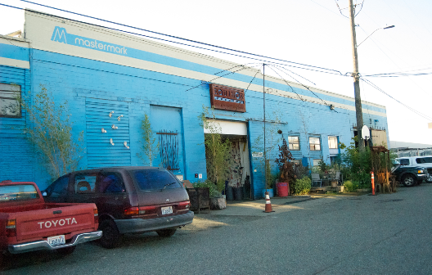
I’m trying to do that with Equinox Studios. We are a complex now of four different buildings, just under 100,000 square feet of cultural workspace, we have almost 125 artists as tenants, doing everything from blacksmithing and metalwork to woodworking, photography, glass, ceramics, music movies, we have two dance studios, painting schools, jewelry, all across the board. I started Equinox back in 2006 when I was trying to find a home for myself and 10 artists who had come from a building in West Seattle that came to an end (strangely, due to the Chinese mafia and a SWAT team storming the place (looking for the owner, not me)). And we were trying to find a home. The original Equinox building was up for sale, and I talked to the owner, and I said, “hey, I can’t buy it today, but I’ll buy it within five years if you lease it to me today.” And strangely enough he said yes, and we got in there and got working, and I was able to buy that building within the first five years, through building equity, by basically remodeling the entire building from the inside out. And within that five years we were able to buy it from a sympathetic owner, he believed in the mission, he believed in the cause, and he believed in me and in the amount of work and time and energy I’d put into the building, and he considered that to be enough of a down payment to finance the building. There were environmental issues we had to take care of, and we got an allowance for that, and we were able to do the deal.
I am Sam Farrazaino, and I’m here to tell you today that I have failed... Big-time.
A couple of years later we started to think about expansion, and found out within a couple of days that the three buildings that were neighboring us were all coming on the market, or were on the market. In one way or another, I realized, I had to get those three buildings. I started with the first one, and I said I have to get this, because I really care about who my neighbors are going to be, and I’d like to expand, and we have so many artists trying to come in here, that it would be worthwhile. So I got it under contract, and then started figuring out how to get the money to buy it. An then the next day, found out about the next building, and did the same, and I was still trying to figure out how to buy it, and then the third day, you get the picture, and soon had all three under contract and I still didn’t have any idea how I was going buy them.

The way to move forward was to look back. To figure out how I had gotten to where I was. And that was, every time my tenants paid me rent, I could pay the mortgage. I started thinking that through, and realized that truly, the end result was that they were all my partners. They supported me in the business, I supported them in the community, and they supported each other. I set off trying to find a way to make them actual partners, and to give them the chance to build actual equity with me in the whole complex. And through a crazily complicated business structure and a lot of time with lawyers and accountants and bankers, we were able to find a way to do that. So now I have 125 partners in Equinox Studios, every tenant, just by paying their rent and being an active member of the community, not by bringing any other money to the table, or any other investment, becomes an owner. And we all build equity over time.

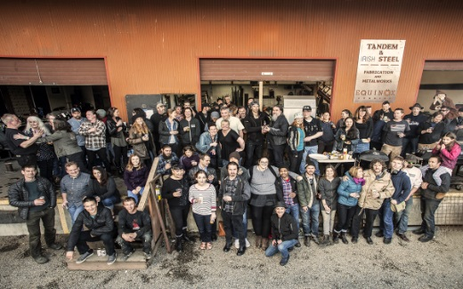
We were able to secure two of the three new buildings, the third we’re still trying to make something happen, but two of the three we were able to purchase, and we were able to do that with partnerships. So I have my 125 tenant partners, and then I have three incredible social impact mission-based lenders; RSF Social Finance, Beneficial State Bank and Craft3 Capital Corporation. They all believe in the mission and have worked tirelessly to help me, and my 125 partners, obtain it.

We still have some work to do, we still have some construction to finish up, but essentially 100,000 square feet of workspace, that will be artists workspace in community for as long as I’m here.

My whole rant is about changing the tired old story of the starving artists who need charity. The artists are incredible entrepreneurs, they’re incredible business people, and they make incredible partners when trying to build something like this. We will be here, and we will continue it for as long as we’re able. We’re also looking to expand even further. Currently we have a waiting list that could fill two more buildings, and we’re working to do just that. I think that we can change the paradigm, and that in Seattle we need to change that paradigm and find innovative methods, not just my own, but all sorts of different methods, whatever we can do, and as fast we can do it, to own property for community benefit.

My question to you is, “What lessons have we learned our failures as a City, and what are you prepared to do today, to start today, to change that? To learn from those failures and find innovative models to secure space for our future and our community’s future?”

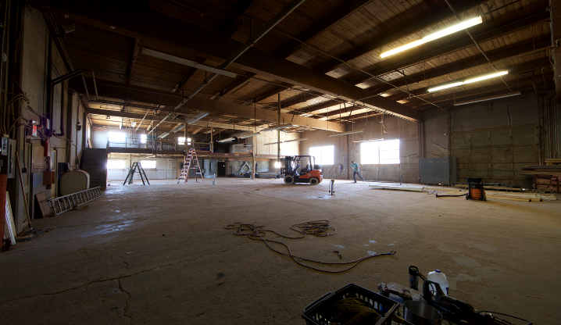
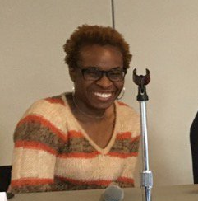
The SouthEast Economic
Opportunity Center
Uche Okezie
Director of Real Estate Development, HomeSight

Good afternoon! We are hoping that the SouthEast Economic Opportunity Center will be the community’s opportunity to put a permanent stake in the ground, with a three-acre project, that preserves and supports cultural diversity and neighborhood character. It’s located at the corner of Martin Luther King Jr Way and Othello, it’s that big empty lot that’s across the street from the Safeway. Our intent is that it will maximize development capacity, because it’s considered a transportation oriented development site, it’s one block down from the Othello Light Rail station stop. It will prevent residential, commercial, and cultural displacement. And it embodies the community priorities that were outlined in the 2009 Othello neighborhood plan. Also it will create a shared multicultural community center to stabilize the existing community based organizations and be a bridge between the larger community and all the different partners that will be located at the opportunity center.

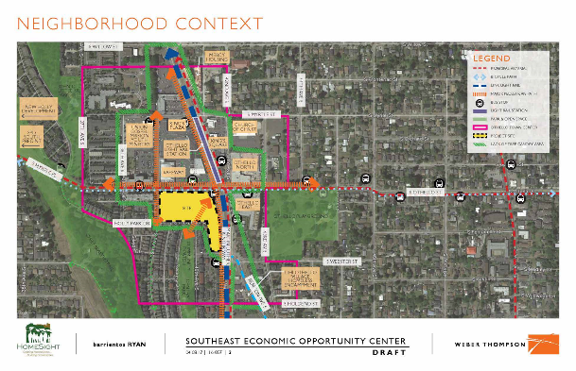
So, you ask, why an opportunity center? The Othello neighborhood has welcomed immigrants for decades, and given them access to affordable spaces. The business district alone is home to over 150 mostly immigrant-owned small businesses as well as cultural anchors, community grass-roots organizations, equitable development coalitions, and places of worship all, firmly rooted in the community. As I said before, this is the community’s opportunity to put a permanent stake in the ground, so that all those things are not lost with the pressures of development that are happening, as Sam and others have said. Property values are rising. For this piece of property, which is currently owned by Seattle Housing Authority, a year ago we signed an option to purchase for $7 million, and their appraisal that came back for this year was for three times as much. So that gives you an indication as to how quickly prices are going up in the City of Seattle.

The Opportunity Center is an opportunity to close opportunity gaps. It was first thought of because of a 2014 study, done in partnership with the Office of Economic Development, SEED, Impact Capital, Cornerstone, in which they studied the feasibility of creating an opportunity center, and outlined the argument for why one was needed. Southeast Seattle needed culturally appropriate access to education, good paying jobs, business services, and national research confirms that people in business startups experience greater economic growth when they can access multiple services in one location. The Southeast Seattle community lacks access to most of those opportunities, and most of the employment, education, social services that are serving the neighborhood currently are several miles north of the center of the neighborhood, and despite low educational attainment in the neighborhood, it is the furthest neighborhood from any post-secondary education institution in the city of Seattle. If the neighborhood were able to develop integrated business and education services, they could provide the backbone for new growth, new jobs, and growth in the community.

So as part of our concept development, we partnered with the City and other Southeast Seattle community coalitions and reached out and engaged and collaborated with several community organizations, business, residents, resident groups that were located in Southeast Seattle to gather input regarding what the program designed for the opportunity center should be. The purpose of this was to inform the community about the project’s progress and to incorporate their feedback into the core elements of the projects so that their vision, goals, and priorities are retained as the project moves forward. This community engagement process coincided with a 9-month feasibility study that Seattle Housing Authority required us to do as part of the Option to Purchase in order to show that this was a project that was feasible, that this was a project that wasn’t going to lose money, that it was going to break ground, and then five years down the road be something that was sustainable.

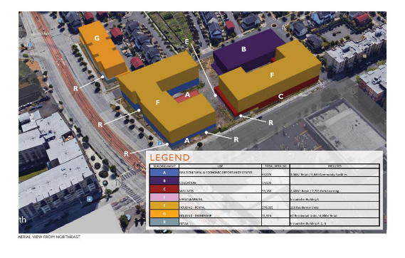
Some of the programs that will be at the Opportunity Center include the Multicultural Community Center, which is a group of nine refugee and community groups that have been working together since 2014. Those groups include the Somali Community Services, Horn of Africa Services, Chinese Information and Service Center, it includes the Eritrean Community In Seattle and Vicinity, Eritrean Association of Greater Seattle, the Oromo Community, Ethiopian Community in Seattle, Urban Family Center, and Vietnamese Friendship Association. They’ve all been working together to find a space where they will not be displaced, because they are all cultural anchors in Southeast Seattle.

There will also be a business technical assistance center, which will be able to give emerging businesses and entrepreneurs an opportunity to get technical assistance, loans, and training so that they can start and keep their businesses. There will also be early childhood education, both classrooms for 0 to 5-year-old children as well as adult education, there will be secondary education provided by Rainier Valley Leadership Academy, a high school that will be located on the site. For post-secondary education, we’ve been working with the University of Washington and Seattle Colleges to provide programming at the site and also STEM programs, which will be provided by the STEM Paths Innovation Network, they’re responsible for starting a robotics program in Southeast Seattle and don’t yet have a brick and mortar location.

We will also provide workforce rental units, affordable home ownership units, and we are looking at making those homeownership units limited equity co-ops. There will be community healthcare services provided by Odessa Brown, which is currently located in the Central District. They want to expand their services to Southeast Seattle, which is where a lot of their clients have started to move. And then of course affordable retail space.

As you can see the site is located close to a lot of transit, so it’s accessible, being on the light rail as well as bus services. The big building that’s along MLK is where there will be affordable rental units, 40% of them are affordable to those making between 60% and 80% of the Area Median Income, and the rest will be 80% and 120%, which really represents the workforce that’s in Southeast Seattle. Here there will be community space, and also at the bottom two floors will also be space for community-based organizations. The orange building will be the limited equity co-op, and on the Othello side will be additional affordable rental units, and Odessa Brown Clinic, and the purple building is the high school.

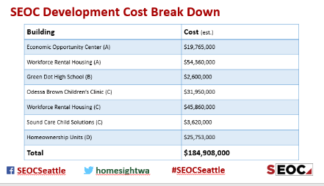
Here is the cost breakdown for the community center, definitely a very huge lift. We are hoping that we will be able to attract social impact investing for the rental housing, Green Dot is working with the Gates Foundation to finance their portion, Odessa Brown Children’s Clinic is also working on financing their portion. Basically we all are looking to be able to provide a mechanism to improve community health and community benefits as well. And with the home ownership units, which is really HomeSight’s bread and butter, we will be able to provide home ownership opportunities for people who are 80% or below of the Area Median Income. We’ve been around since 1990 so we definitely have expertise in that. The SEOC is an example of the many partnerships that we have been able to incorporate to make this project happen.

Right now, we’ve just signed a term sheet with the Seattle Housing Authority, which has been definitely a heavy lift. The purchase price that’s on the table is $14.2, which is great because it was appraised at $20 million, and I think that’s because of the community benefits we will bring with this project. And we hope to sign the purchase and sale agreement with them at the end of this month.

And then of course, design and permitting begins, starting with the High School they will be the first on the site, and then everything else follows. We hope that our schedule doesn’t slip, and we will be able to open in the winter of 2022.

I just wanted to say that the purpose of the Southeast Economic Opportunity Center is to bring about economic growth by creating access to needed community services – childcare, social services, education, job training, so that everyone in our community can successfully compete for the kind of jobs that pay a living wage as well providing growth and skills. As we know, more is possible as a community than alone and that is really what the opportunity center is building on.

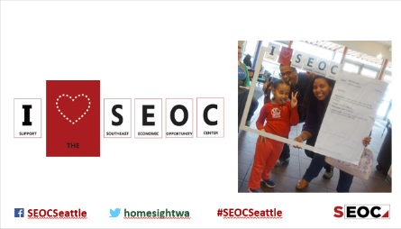
The Break-Out Sessions

Following another short break, the Square Feet event continued with a series of “break-out” sessions. Eight presenters each carrying a placard with their name and subject matter on it spread out to various corners of the space. The audience was invited to wander and listen in on sessions that attracted them.

Th eight presenters of the Break-Out Sessions are listen below, with a paragraph from each about their talk.

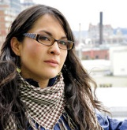
Julie-C
ACED: Artist Coalition for Equitable Development
Degentrify & Inspire

Artist Coalition for Equitable Development is an assembly of autonomous artists, cultural organizers, and activists dedicated to preserving and nourishing the soul of the city through coordination, creative advocacy, and direct action.

Mission: To advance an innovative approach to growth in Seattle that harnesses the power of arts and culture as a gauge, moral compass, and catalyst for equitable development.

What equitable development means to us:

- Centering the interests of Seattle's most vulnerable communities and people over big business and politics through transparency, inclusivity, and empowerment in the development process.

- Honoring and growing the living historical legacies of Seattle neighborhoods and cultural spaces through fostering community agency and ownership over development projects.

- Mitigating and healing the detrimental social impact of gentrification and economic displacement through investing in local arts and culture and creating more dedicated spaces for artists to live, work, and thrive.

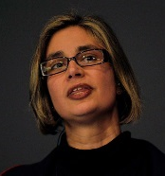
Michelle Dunn-Marsh
Photographic Center Northwest
The Thirty-Year-Old Startup

The Photographic Center Northwest is in the early planning stages of a project to rebuild the center on its current site, and to include affordable housing in a mixed-use project that would take advantage of new zoning and building codes.

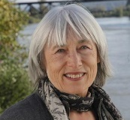
Karen Guzak
Sunny Arms, Union Co-Op Developer
Creating Co-Ops for Artists: The Ins and Outs

My Square Feet session, Creative Financing, explored alternative forms of ownership for artists, using the cooperative form – a relatively little-used legal structure, where the members own shares of stock in the corporation that owns the building. My two examples of the projects I developed are the 35,000 sq/ft five-story cast-concrete Sunny Arms, near Georgetown which was originally built in 1907 to house Washington Shoe; and Union Art, on Capitol Hill. It is 32,000 sq/ft with twelve artist’s units, built in the early 1900's as an auto dealership. It won the AIA Seattle Time Home of the Year Award. I founded Sunny Arms in 1989 and Union Art in 1993 with my partners, Lois and Gene Graham.

Unlike a condominium, where purchasers buy a finished unit, owners of a cooperative purchase both shares of stock and a master lease to a particular physical space in a then undeveloped building. Individual units were initially laid out with tape on the floor and an architectural plan delineating common spaces. We members formed a governing board and shares were voted on a prorate basis to handle the many decisions that flowed from purchase of the building, through development, construction and occupancy. Both projects took about two years from inspiration to inception to completion.

These projects came out of my own need for a stable place to live and work, and my desire for a community of artists. I sold my home, and put together the groups that were able to purchase and renovate these buildings. Due to the age of the buildings, the prior use and the proposed use for artist's space, neither project qualified for standard financing. Thus, the idea for a cooperative that was owner and group financed as we developed the spaces. I wrote the sales prospectus, working with legal help to create the governing documents, and collaborated with Patricia Brennan architects to lay out the spaces. We had weekly meetings as we worked through the many details of construction and community creation.

Both projects provided relatively low-cost ownership options, as the real estate market was languishing in those days. We negotiated seller financing for the purchase of the buildings and found the cooperative form of ownership allowed us as a group to pay over time. It is seldom these days to find seller financing, but the two buildings that we bought had been vacant for several years, and the sellers were open to selling the buildings on a 15-year contract. All the artist / owners had some financial means, and we saw multiple strategies for financing of each individual unit. Since these projects are finished, and fully occupied, the National Cooperative Bank has refinanced a number of the units.

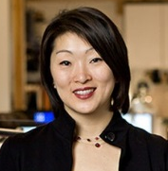
Grace Kim
Schemata Workshop
The Power of Community-Oriented Housing
Cohousing is community-led housing model where people know and care about their neighbors. Each resident has their own home but also has access to significant share common areas. At Capitol Hill Urban Cohousing (capitolhillurbancohousing.org) we not only adopted this model, but incorporated strategies for affordability. While the residents own the building through a self-formed LLC, they are also renters from the company. This allowed the LLC to receive property tax abatement through city’s MFTE program. This allows 2 of the 9 households to pay significantly less per month in rent based on income restrictions. The rental model also allowed for easier access to housing stability. Rather than a large down payment for a home, each household came up with $30k of membership fee to become a member, reducing the barrier to join.
While this is not a home ownership solution, our urban cohousing community enables people to live interdependently, reducing social isolation and loneliness while providing housing stability in high opportunity neighborhoods.

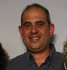
Miguel Maestas
El Centro De La Raza
Developing Community Cultural Space
El Centro’s collaborative, inclusive approach has resulted in forward-thinking
design to ensure Plaza Roberto Maestas sets a new standard for community transit oriented development. By design, this project will foster the Beloved Community for which Roberto Maestas never lost sight. Guided by El Centro’s values, Plaza Roberto Maestas is a model for how development projects can renew, rather than deplete, a community.

As principal founder and long-time executive director of El Centro de la Raza,
Roberto Maestas’s life and work were guided Dr. King’s vision of the “Beloved
Community” – a world where poverty, racism, and social inequality could be
eradicated through multiracial unity and community and civic engagement.
Maestas, along with other community leaders, had long dreamed of expanding El Centro’s mission on Beacon Hill, creating a community that fully embodies the values that El Centro has promoted since its inception.

Plaza Roberto Maestas is a mixed-use affordable housing project located directly south of El Centro de la Raza’s current historic schoolhouse building, and adjacent to the Beacon Hill Light Rail Station. Affordable housing, commercial, and retail uses are situated in two buildings, flanking a public plaza maintained by El Centro de la Raza and open to the neighborhood. The affordable rental apartments are available to residents making 30%–60% of Seattle area median income ($26,000–$52,020 for a family of four).

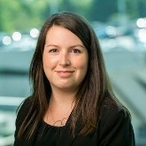
Alix Sales
City of Vancouver, British Columbia, Canada
Let’s Make a Deal

As part of city planning, Vancouver negotiates with developers during major rezonings for in-kind or cash “Community Amenity Contributions” (CACs) to support new capital infrastructure projects such as parks, housing, childcare, libraries, community centres and cultural facilities.

In the last decade, these contributions have resulted in 12 new City arts and cultural spaces - over 150,000 square feet – that provide low cost secure space for over 30 local arts and cultural organizations. Examples of new cultural spaces that are underway or recently completed include:
- Thirty units of low-income artist housing and 4000 sq. ft. of artist production space (View the council report (2.4 MB))
- 10,000 sq. ft. of artist studios View Recent Council Report and Call for NPO operator
- A 7-story, 21,000 sq. ft. cultural hub View council report (7 MB)
- BMO Theatre a 48,000 sq. ft. centre shared by two major theatre companies with a 260 seat theatre, 4 rehearsal halls, costume shops, and offices.
In 2014 - one of the more innovative projects was a $4.5m cash CAC that was granted to four local arts organizations to support artist production space. One artist run centre, Western Front, was able to buy their space and another, grunt gallery, paid off their mortgage. View Council Report

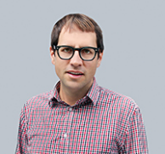
Michael Seiwerath
Capitol Hill Housing
Stabilizing the Arts on Capitol Hill

So many of the presenting arts organizations on Capitol Hill are renting old buildings and completely dependent on their landlord for their survival. Without proper exhibition or performance space, these organizations could cease to exist. Could Capitol Hill Housing, as the neighborhood Community Development Corporation, help them find a permanent home? CHH is seeking to purchase existing arts space – not for redevelopment – but to keep these arts organizations in the neighborhood.
The Large Foam Check Challenge

What is the Large Foam Check Challenge?

The Large Foam Check Challenge is the name the Office of Arts & Culture has given to the program of inclusive budgeting and community-lead directing of resources around cultural space issues.

At each Square Feet Seattle convening, the event’s attendees are invited to develop an idea (through a process that is both collaborative and competitive) that the Office should fund. Resources are dedicated beforehand (the exact dollar amount varies by event, at this year’s event was $10,000) and at the event a project is articulated that will receive the support.

The recipient project, the “winning idea,” is developed through a series of conversations at break-out tables, facilitated by the Facilities and Economic Development Committee of the Seattle Arts Commission. Attendees rotate from table to table, and a series of ideas is developed and all ideas are presented to a jury of peers. At this event the jury was made up of all the presenters from earlier in the program.

Six large tables were set up in the space, and each table was assigned a theme (attendees self-selected themselves to their initial tables based on those themes). Each table was tasked with brainstorming an idea that could be addressed with $10,000, related to the theme. The six themes were:

- City-Owned Properties
- Creative Financing
- Partnerships & Joint Ventures
- Community Ownership
- Land-Holding Models (PDA’s, Land Trusts, etc)
- Open Sky (No pre-set theme)

The Six Ideas:
Each team was invited to make a two-minute pitch to “the Jury” selling their idea. The six ideas are presented below.

Group #1: City-Owned Properties
We have a great idea. Our idea to use City-owned spaces is to ask the young people in the community what they want to use City-owned spaces for. Our event is called Pop-Con, and it is a youth-led exploration to create a youth-only art & culture space in a City-owned property. (Youth being defined as 13 to 21 years old.)

What we’re going to do it use our $10,000 to have a long outreach process, definitely race & social justice-informed, and that whole process, once young people in the community know what’s coming up, is going to be this one-day event, Pop-Con. Youth will be thinking about this on the way up to it, and then once they’re there, for this event (that just happens to be a lot like the event we’re at today), then all of them are going to come together, explore their ideas, maybe switch around groups and make their ideas better, and then the community is going to vote on the ideas, and we’ll have saved at least $500 of the award, to give out to the person who has the best idea, as voted by all the folks who show up that day.

We want to make sure that what the properties are, and what they look like, are accessible to the young folks, so we’re looking at a really cool map, actual printed maps and also an interactive map. And then a list of what they are and mini-descriptions, and also definitely using social media (we already have a hashtag, #popcon!)

Group #2: Creative Financing
We were talking about creative financing, and crazily enough, we also had an idea for an event that looks a little like this, which would be the “Financial Therapy Expo: How to Solve Your Cultural Space Headaches.” We would convene lenders, foundations, developers, arts entrepreneurs, and welcome individuals and offer pragmatic, specific examples from experts in their fields in panels and small groups, sharing their success stories, what they learned from mistakes over the years, or over their trials and travails in developing cultural space.

We had a focus on one-on-one mentoring, so a speed-mentoring with financial experts, so many of these projects are so specific to the group or individual trying to get them off the ground, that someone with expertise, to really listen to what folks are really struggling with right then would be beneficial.

In light of that, in terms of the specificity, it’s sort of a dual venture, we’ve got the financial therapy expo, and then an online resource, a web and digital communication platform, that offers resources for project leaders needing to learn about financing, shows case studies for different sized projects in different jurisdictions, and how they’re financed, and then a means of entering some of your own statistics – “We’re an X-sized organization in such-and-such area, looking to build a project of X-size and dollar amount, etc…” And the website responds to those answers and gives you some resources that might be helpful – “These are some funders who deal in loans of that size, etc…” And potentially that’s done in advance of the expo, so you can select yourself into groups at the Expo based on that.

Group #3: Partnerships & Joint Ventures
We propose to create an active strategy to develop creative acts, that shifts how we think, and define, the economy. And that strategy would include leveraging a situational analysis or research. Moy talked about Denver, New York, Houston, London, all of these cities in the past two years have created reports on the Creative Economy. And a number of those reports cite Seattle as a case study.

We need to do a situational analysis and a lit review of that very research and inform it to see what do we say about our city, what can we use from that then to create environments? So we go from situations to environments, and those environments would be a set of recipes, a set of prompts. Think of Mad Libs, but for Seattle: “I am an arts based organization, I am an artist, I earn this much, I pay this much, I want to do this…” And then we can use those prompts to actually create conversations, it would be a series called “Let’s Have Dinner and Talk About Creating Acts of Shifting the Economy,” and we would take those conversations from those dinners that then would contextualize the very impacts. Because we want to in a sense, if we’re going to have communities of practice, we need places and spaces to practice what it means to become community. Because we don’t know how to do that very well.

So we need to actually practice that through these dinners, and if we’re going to look to create interventions for communities, the criteria of impact need to come from the communities themselves, otherwise we’re just going to be doing things onto communities, rather than having it done with.

So a creative strategy that shifts how we think about the economy and be a focus, and actually designs impacts that matter for a contextualized world view. And we call it The Pad and the Table.

Group #4: Community Ownership
We were inspired by the $3,000 tiny house solution to homelessness that was recently showcased at the Seattle Design Festival, and also by the personal equity pay-it-forward models like Equinox Studios, Bikeworks, and Habitat for Humanity. So we have a Tiny Space for Community model. We would have land donated by the City or by a philanthropic landowner, we would choose a community, an underserved or affected group, who would be an appropriate community for that particular plot of land, put a tiny space on that lot, and give that space to the community to decide what they need to do with it.

Then from whatever revenue was generated by this space, and generated by any programs, plus the equity in the structure, would be used to pay it forward into the next tiny space for the next community, and the next tiny space for the next community.

Use the funds to build the space, and administer the process of identifying which community gets the space, and then use the community to design and build the space, and give any other resources to the community to support whatever other community vision is there.

Group #5: Land-Holding Models (PDA’s, Land Trusts, etc)
We started in our group talking a lot about the problem, and the problem is that a lot of us, individuals, artists, even small organizations, don’t really know how to buy their own cultural space (as much as we want to). And as we learned today, buying your own cultural space is really the way to maintain your destiny and keep those spaces into the future. But we just don’t know how to do it. So we talked about land trusts, and we looked at models including the one presented by today’s keynote speaker, which we loved, but we were concerned that replicating an organization like that in Seattle might only be able to serve two or three projects a year, or only be able to serve larger projects. So what we really wanted to do was empower more people to get involved in that buying process.

So we envision a Cultural Space Ownership Council, and that Council would be made up of people from the City, it would be made up of PDA’s, nonprofits, people from the creative financing realm, developers, and individuals and artists who want to own, or buy, cultural space. So it would be sort of like those TV shows, the reality shows, where you pick a project, so we would have quarterly meetings, and at each meeting we would have three or four presentations from artists, communities, or small nonprofits who want to purchase a building, and they would get direct feedback from the Council. A developer would listen to their pitch and say, “This is yes, this is no,” a financier would listen and say, “Have you considered these…” In addition to the direct feedback at the time of the meeting, we would hope that they would create connections and linkages that could empower smaller groups to purchase their own cultural spaces.

Effective communities of culture. The $8,000 would be used to fund a study to explore how this could be structured to make this a sustainable initiative, something that can happen regularly, say every quarter.

Group #6: Open-Sky Ideas
We were the “Out of the Box” table, and we would just like to say that the crypto-currency is a really interesting idea, but we don’t feel like we know enough to really give it a real pitch, so I’m just going to give anyone who wants it Sandy Cioffi’s phone number…

We liked what a lot of people said about bringing people together. Moy had that circle, about bringing people together, which included arts people, it included financiers and real estate people, and we want to make more friends on that side of the bubble. So we agreed that bringing those people together at events like this, where we need more of those folks, would be great. We also would like to have, inside of that group, an Ambassador. So that Cultural Space Ambassador is a citizen, who would be sort of visible within that community (we nominated Don Blakeney for the first one), but someone who would be a good link between the arts community and the financial community.

So if these events are coming together let’s say quarterly, there would be four of them, and we’d like to commission four pieces of artwork that are going to be created in artists’ teams with a real estate developer, a financier, a property owner, and a designer, paired with artists on the other side, to create a piece of work together, and present those at these quarterly networking and programming events that would take place to bring community together.

The Jury convened together with Randy Engstrom from the Office of Arts & Culture. Those deliberations were private. Following the deliberations, Randy made the following announcement:
Randy Engstrom: Hey guys, want to know who won? Good news: literally everything won. But it’s complicated because we’re government.
Moy Eng: It’s nuanced.
Randy Engstrom: It’s layered. The part about Scott’s transformational scenario planning, what he presented up here with Mytoan and that group, that is work that is happening, and that this gives a little more weight and context to, and it’s also tied into the youth center. How do we center youth voice in how we do this work both in research and in programmatic design? Which Moy has volunteered to help us think about. So that’s an area of research and program design planning that was already going to happen, but now I think it’s going to happen better.
There’s clearly a need for regular technical assistance and ongoing support around real estate, finance, lending, ownership models, land trusts, PDA’s, CDC’s… we need to keep that conversation going. That conversation is going to live, and thanks Sam for volunteering, at the Facilities and Economic Development Committee of the Arts Commission, which really has been stewarding this work for 15 years, and now it’s getting clearer where that need is and how frequently that support is going to be needed moving forward. We have Deb [Twersky] here from 4Culture, who’s been pushing real estate and space conversations for a long time, they’re part of the SpaceLab NW project that Matthew talked about, so there’s some work to do to figure out the programmatic model for that, but we have this space, forever. Guess how many quarterly meetings we could do in here? All of them. I mean we have to come up with a staffing model for it, because events aren’t free, but I think if there is a need for focused technical assistance, and coaching, and support, we have a way to make that happen. And I think that’s also tied into several of the CAP Report recommendations around staffing and capacity and what the true need is.
So five out of your six things are done so far.
And the sixth thing, which was a totally new idea, which I think we would just need to cut a check to make happen, is Tiny Spaces for Community. And we know for example that the City owns all these tiny weird pieces of land called snippets, we know that we know people who can make or build or acquire these tiny units of space, and why not try it? We have $10,000, we’ll put that on the table and see what we can come up with, and we’ll see if we can make this leapfrog model work, and dot these things all around the city, and have each of them really reflect the community that they’re in.
So congratulations!

The Tiny Spaces for Community brainstorm team celebrates their win in the Large Foam Check Challenge.
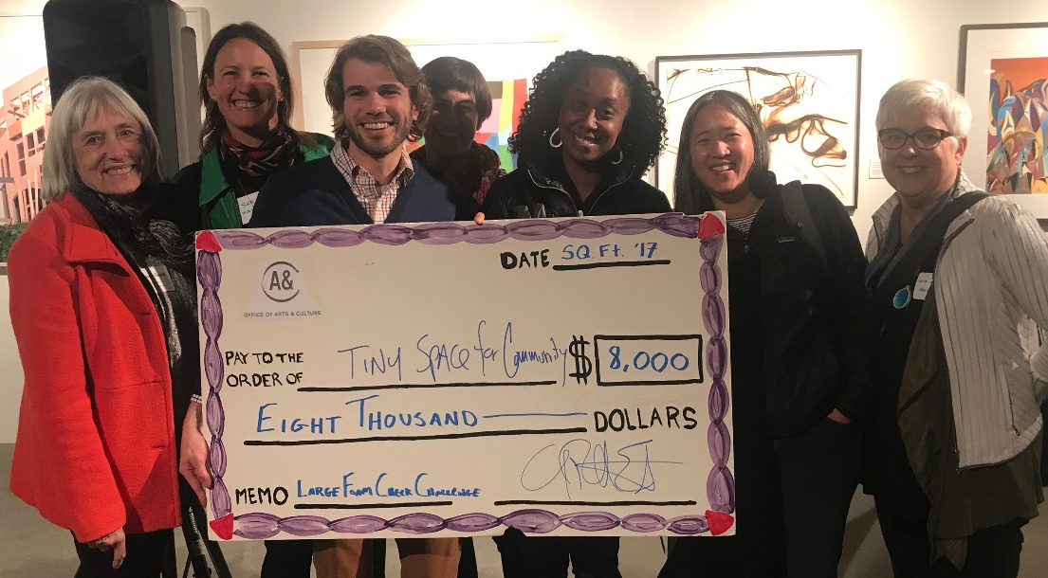
Note: The “Large Foam Check” in the image was written out for $8,000, which was raised to $10,000 following the event.

Following the Square Feet event, the Seattle Office of Arts & Culture contracted with Sawhorse Revolution to operationalize the Tiny Cultural Spaces for Community idea.

sawhorserevolution.org
“A revolution to rebuild our communities through carpentry,
design, and education”

Sawhorse Revolution is a local nonprofit organization specializing in building affordable (and tiny) homes for the homeless, teaching trade skills to youth who construct the projects, and empowering communities with design control and collaborative processes. As of this writing, that contract is just getting underway.
Closing Remarks
Randy Engstrom, Director, Office of Arts & Culture
I’ll close by sharing Seattle Arts Commission Chairperson Vivian Phillips’ closing thoughts, which she shared with me before she left. I wrote them down, because you don’t want to misrepresent what Ms. Vivian says…
One: Don’t give up. Kudos to us all for not giving up, we just decided we’re going to do all six things…
Two: Failure is okay. These aren’t all going to work, at least not the first time, and that’s also okay, because we’ll try again.
Three: Three years ago, this space was a vacuous dusty empty rom that wasn’t used for anything, it was vacant for thirty years. And now it’s going to do this, forever. Which is a little bit hopeful, because in that time was this insane real estate escalation, and all the challenges that come with it. So that goes back to the don’t give up part…
And finally, I think that the idea that there aren’t any resources here is a myth. There are lots of resources here, they are not yet going towards these conversations at the scale that we would like. But you could throw a baseball if you had a good arm and hit several very well-endowed corporations and foundations that are within sight of this building. We just need to start to build our case, tell our story, and as was said by Alix to bring some more of these people to the table, to expand who we’re having the conversations with, we have to find the others.
But I don’t think that resources are the thing that’s going to stop us from doing it.
So thank you for being here, thank you for giving us six new things to do as an office (sorry staff), and enjoy your pizza.

